

Journal of Public Economics 213 (2022) 104713
Contents lists available at ScienceDirect

Journal of Public Economics

journal homepage: www.elsevier.com/locate/jpube


Simulated power analyses for observational studies: An application to the Affordable Care Act Medicaid expansion ^{q}
Bernard Black ª, Alex Hollingsworth ^{b,}⇑, Letícia Nunes ^{c}, Kosali Simon ^{b}
ª Pritzker Law School and Kellogg School of Management, Northwestern University, United States
^{b} O’Neill School of Public and Environmental Affairs, Indiana University and National Bureau of Economic Research, United States
^{c} Insper - Institute of Education and Research, Brazil

a r t i c l e i n f o

Article history:
Received 11 February 2019
Revised 29 December 2021
Accepted 5 July 2022
Available online 29 July 2022

JEL::
C15 I13

Keywords:
Simulated power analysis Health insurance Mortality
Medicaid expansion
a b s t r a c t

Power is an important factor in assessing the likely validity of a statistical estimate. An analysis with low power is unlikely to produce convincing evidence of a treatment effect even when one exists. Of greater concern, a statistically significant estimate from a low-powered analysis is likely to misstate the true effect size, including finding estimates of the wrong sign or that are several times too large. Yet statistical power is rarely reported in published economics work. This is in part because many modern research designs are complex enough that power cannot be easily ascertained using simple formulae. Power can also be difficult to estimate in observational settings. Using an applied example–the link between gaining health insurance and mortality–we conduct a simulated power analysis to outline the importance of power and ways to estimate power in complex research settings. We find that standard difference-in-differences and triple differences analyses of Medicaid expansions using county or state mortality data would need to induce reductions in population mortality of at least 2% to be well powered. While there is no single, correct method for conducting a simulated power analysis, our manuscript outlines how applied researchers can conduct simulations appropriate to their settings.
© 2022 Elsevier B.V. All rights reserved.

- Introduction

In a typical research setting, when an estimate is statistically indistinguishable from zero, a researcher may conclude that a

^{q} We thank Marcus Dillender, William Evans, Ted Joyce, Anuj Gangopadhyaya, Robert Kaestner, Amanda Kowalski, Sarah Miller, Dan Sacks, Jeanette Samyn, Ben Sommers, Coady Wing, Susie Van Doren, Engy Ziedan, and participants in workshops at the Bar-Ilan University Conference on Law and Big Data (May 2018); Georgia State University, Economics Department (August 2018); Hebrew University of Jerusalem, Economics Department (Nov. 2018); Interdisciplinary Center Herzliya (May 2018); ASSA 2018; Stanford University Health Economics Seminar (May 2018); ASHEcon (2018); APPAM (2017); Tel Aviv University, Economics Department (Nov. 2018), Texas A&M (May 2017); and UK Institute for Fiscal Studies (Nov. 2018). We also thank the Editor and two anonymous reviewers. A replication package related to this project can be found here, https://doi.org/10. 5281/zenodo.6653213. This package contains all publicly available data and instructions on how to obtain restricted access data. Code for the project can be found here, https://github.com/hollina/power-analysis. A simulation example with publicly available data can be found here, https://github.com/hollina/health_ insurance_and_mortality.
⇑ Corresponding author.
E-mail addresses: bblack@northwestern.edu (B. Black), hollinal@indiana.edu (A. Hollingsworth), leticiafcn@insper.edu.br (L. Nunes), simonkos@indiana.edu (K. Simon).
studied treatment has no apparent effect or that there is a wide confidence interval. Similarly, when the estimate is large enough to be deemed statistically different from zero, a researcher may report that there is a treatment effect, providing their point esti-mate as a best guess of its magnitude. However, without consider-ing statistical power, both of these seemingly reasonable conclusions are incomplete.
Statistical power is the probability that an estimate will be found to be statistically significant when the true treatment effect is non-zero. A conventional measure of whether an analysis has sufficient power is whether the study—if repeated many times across different samples—would find a statistically significant effect at least 80% of the time using a two-sided test with a 5% significance-level.
Power is an important consideration whenever a treatment induces small changes in an outcome relative to its underlying variation. If the underlying variation is large, a small treatment effect, even one that would be economically important, may not be large enough to be statistically significant. Thus, analyses with low statistical power are unlikely to produce convincing evidence of a treatment effect even when one exists. Of greater concern, a statistically significant estimate from a low-powered analysis is

https://doi.org/10.1016/j.jpubeco.2022.104713 0047-2727/© 2022 Elsevier B.V. All rights reserved.

likely to overstate the magnitude of the true effect size, and can lead to estimates of the wrong sign or with magnitudes that are several times too large (Gelman and Carlin, 2014). This occurs because tail estimates that are much larger than the true effect are more likely to be large enough to be statistically significant. Thus, without considering statistical power, it is difficult to inter-pret both statistically insignificant and significant estimates.¹
Despite this importance for inference, estimates of statistical power are rarely reported in published economics work. This is in part due to the difficulty in measuring power. For the simplest statistical models, power can be calculated using formulae and canned statistical software. However, as the complexity of a statis-tical model grows, a closed formula is often not available. For example, only recently did Burlig et al. (2020) derive a power for-mula for the common experimental setting of difference-in-differences with clustered standard errors.
Power analyses are most commonly conducted when designing an intervention where the researcher has control over parameters that affect power (e.g., size of expected treatment effect, number of treated and control subjects, and covariates collected). These set-tings are conducive to the use of simple formulae to estimate power before the intervention occurs. However, much of modern applied work studies observational settings, where the researchers may not know—and usually have no ability to manipulate—the expected treatment effect or other parameters that can affect power. Observational settings are less likely than experimental set-tings to have clean research designs, as concern for identification often requires a complex design for which a power formula may not exist.
To explore these issues, we examine an applied setting–the effect of gaining health insurance on non-elderly mortality. Most sources of U.S. mortality data do not contain information on the decedent’s health insurance status or income. To overcome this data limitation, researchers often exploit policy changes that affect health insurance status at an aggregate level (e.g., state-by-year Medicaid expansion under the Affordable Care Act). Since many people already have health insurance, a regulatory change that increases access to insurance will affect insurance status only for a minority of the population. An effect of gaining insurance on mortality, for those persons who gain insurance, could be econom-ically important for those persons, yet statistically insignificant for the population as a whole, against the background of variation in other causes of mortality. Recent research using detailed individual data and strong research designs has provided robust evidence that health insurance decreases mortality (Miller et al., 2021; Goldin et al., 2021).² In this paper, we study power in a related setting, ask-ing if a true effect of insurance on mortality can be detected using population data, and if so how large would the effect need to be to yield sufficient statistical power?.
The Affordable Care Act (ACA) substantially expanded health
insurance coverage for the low-income, non-elderly adult popula-tion through both expanding Medicaid and creating marketplaces with private insurance subsidies. While every state created a sub-sidized marketplace, only some states chose to expand Medicaid eligibility. This setting provides an opportunity to study the link between health insurance and mortality, as well as to examine issues of statistical power in natural experiment studies. We focus on near-elderly (55–64) mortality, both because this age group is more likely than younger persons to have health conditions for

¹ The potential for underpowered studies to produce misleading results is exacerbated by file-drawer bias, in which statistically insignificant results are less likely to be published, and by non-pre-specified research designs, in which researchers often explore different sample and regression specifications and are more likely to report those producing statistically significant results (Ioannidis, 2005).
² See Kaestner (2021) for a critique.
which healthcare is important for survival, and because this pro-vides a comparable group in the young-elderly (65–74), who did not experience an insurance expansion. We consider two natural experiment research designs. First, a difference-in-differences (DD) comparison that estimates how the gap between the non-elderly mortality rate in Medicaid expansion versus non-expansion states changed before and after Medicaid expansion. Second, a triple-difference design that incorporates an additional comparison between the near-elderly and young-elderly in the same geographic units, which can control for county or state-specific mortality trends, not captured in the DD design.
For each research design, our empirical strategy proceeds in three stages. First, we examine the reduced form relationship between Medicaid expansions and insurance coverage, which will help interpret aggregate treatment effect estimates of mortality. Second, we obtain point estimates of the relationship between Medicaid expansion and population mortality. Finally, we conduct a simulated power analysis, in which we impose known treatment effects of varying sizes and measure how power varies with the imposed effect, to assess the smallest effect size that could be detected with sufficient power using our data and research designs.
We illustrate the statistical challenges of studying our research question using this design in a way that is intended to be broadly applicable to other questions and designs. In particular, we use a simulation-based approach to obtain estimates of statistical power and minimum detectable effect sizes that can be adapted to a vari-ety of settings. Traditional power analyses rely on closed form mathematical solutions and are only available for simple statistical models. Many modern, complex research designs have no corre-sponding power formula. Researchers, who do not have access to a closed formula must choose between not conducting a power analysis, conducting a power analysis for a different, simpler model with the hope that the results are informative for the actual, more complex model, or performing a simulation. The steps to perform a simulated power analysis are not identical across every setting and the most appropriate simulation will be idiosyncratic for each pro-ject. A goal of this paper is to serve as a guide for other applied researchers seeking to conduct their own simulated power analysis by outlining how we determined and conducted a suitable simula-tion for our research design.
We conduct our simulated power analysis by artificially intro-ducing treatment effects of different sizes into untreated, but real population data, drawn from the pre-Medicaid expansion period. We do this many times, randomly assigning treatment at the state-level in each iteration. After imposing each pseudo-treatment effect, we run both the DD and triple difference specifi-cations, recording the coefficient and p-value for the artificial treat-ment effect estimate. For each imposed effect size, we use this information to compute the percent of times a treatment effect is found to be statistically different from zero (i.e., power) and the minimum effect size that has 80% power at the 5% significance-level, known as the minimum detectable effect size (MDE). Condi-tional on an estimate being statistically significant, we record the rate of severe magnitude errors (which we define as an estimate more than twice the imposed effect size) and sign errors (i.e., an estimate with the wrong-sign). We also examine how power and the MDE vary as we perform the same analysis on subgroups of interest that may be more strongly affected by the Medicaid expansion. Finally, we demonstrate how particular simulation choices affect our power estimates.
There is no uniform method for conducting a power simulation.
However, a key goal of this manuscript is to highlight issues that will appear in many efforts to use simulation to conduct a power analysis and to guide researchers in constructing analyses suitable for their research settings. Consider just a few decisions that a

project may face: 1) the choice between using real, but untreated data, or entirely artificial data; 2) how to select untreated units to be pseudo-treated—should they be drawn from the pre-treatment period or from never-treated units? and 3) how to impose the treatment effect—for example, should all units receive an identical treatment or should the pseudo-treatment be drawn from a distribution? When possible we present power estimates that show the effect of varying each of these choices.
In our research context, we find that Medicaid expansions resulted in average coverage gains of around 2% for those aged 55–64, with some subpopulations (e.g., Hispanics) seeing larger gains.³ Using county-level specifications, we do not find a statisti-cally significant relationship between insurance expansion and decreased population mortality. However, with state-level data and a triple difference specification, we find evidence for a statisti-cally significant decrease in population healthcare amenable mortal-ity in Medicaid expansion states of around 1.53%.⁴ However, we find that the MDE for standard difference-in-differences and triple differ-ences analyses of Medicaid expansions using county or state mortal-ity data is at least 2%. Power simulations for this specification show that when the true, imposed population treatment effect is 1.53%, statistical power at the 5% significance-level is around 51%. We also show that when using our two research designs, focusing on sub-populations that were more affected by the treatment does not improve statistical power. This is because the increased variance in mortality for these subgroups offsets any power gains from poten-tially greater treatment or a larger share of the population gaining insurance. Finally, we show that if individual-level data reported both mortality and insurance status, much smaller treatment effects could be reliably detected with sufficient power.
We note several caveats related to our work. First, our analysis
is primarily focused on power analysis and does not examine whether insurance affects mortality; several recent studies answer this question (Goldin et al., 2021; Miller et al., 2021). Second, we caution against the interpretation that a low-powered study con-tains no important information, instead we suggest that statisti-cally significant results from a low-powered analysis should be interpreted with caution and that statistically insignificant results from a low-powered analysis should not be viewed as evidence of no effect. Third, we also caution against using discrete thresholds to indicate whether or not a study has sufficient power. Estimates of statistical power are an important piece of information that can be used to evaluate the strength of an empirical result, but are only one metric. Fourth, we do not recommend conducting post hoc power analyses that use treatment effects estimated from regres-sions using the actual sample; instead we recommend estimating power by perturbing real, but untreated data by imposing a known treatment effect.
Our paper proceeds as follows. Section 2 provides a background on statistical power, power in the economics literature, and an introduction to simulated power analyses. Section 3 contains all information unique to our idiosyncratic setting: summarizing prior work examining the link between health insurance and mortality, the data used in our study, and our estimates linking Medicaid expansion to insurance enrollment and mortality. Section 4 outli-nes details of our simulated power analysis, results, and sensitivi-ties to specification choices. Section 5 concludes.

³ This estimate of expanded insurance coverage could be attenuated due to documented under-reporting of Medicaid enrollment in survey data and the availability of conditional/retroactive coverage (Davern et al., 2009; Marton and Yelowitz, 2015).
⁴ The county-level and state-level specifications produce different estimates due to different regression weights. We use inverse propensity score weights so that weighted control observations will be similar to treated observations on observable covariates. Weighting for balance on state–rather than county-level characteristics–leads to different point estimates.
- Background on statistical power

Power calculations can be useful in many settings. Discussions of power in economics typically relate to one of two broad goals. The first is to determine statistical power for literatures or specific questions of interest through the meta-analysis of already com-pleted studies. The second—and the one most related to this manu-script—is to assess the statistical power of a specific research design for a given project. By definition, power for meta-analyses must occur after treatment has occurred. However, power for a specific study can be assessed before or after treatment occurs. The ability to conduct an ex ante power analysis can be valuable in planning a study design and these analyses are often used in the design of randomized controlled trials (RCTs).
In this section, we first document the rarity of power in pub-lished economics work. We then discuss attempts to estimate sta-tistical power for studies within economics and outline differences between ex ante and ex post estimates of statistical power. Next, we explore how observational data and research designs introduce challenges to using closed form formula for estimating power. Finally, we discuss how simulated power analyses can alleviate some of these challenges.

  - Statistical power in the economics literature

Presence of power in published work: The simplest attempts to document concern for power involve simple keyword searches of published work. Examining a sample of empirical papers from the American Economic Review in the early 1980s, McCloskey (1985) finds that none of the papers mention the word power; examining all empirical papers published in top economic journals in the 1980s, McCloskey and Ziliak (1996) find that only 4% men-tion power and 1.1% examine the power function.⁵ In a similar vein, we searched for the phrase ‘‘power analysis” in published and work-ing economics papers and in pre-registrations. We found very few instances of the phrase, indicating that power analyses are not typ-ically reported in published economics research.⁶ This does not mean that economists do not conduct power analyses, as many grant applications require them, but merely that they are not reported in searchable text in the listed databases.
Concern for power in collections of economic studies: A lack of reported power has not prevented a number of efforts to esti-mate statistical power in economics. A growing literature across several fields, including economics, documents the frequent appearance of underpowered studies, as well as the potential causes and implications (Button et al., 2013; Maxwell, 2004; Ioannidis, 2005; Ioannidis et al., 2017).
Using data collected from top economic publications in the 1980s and 1990s, De Long and Lang (1992) argue that many null hypotheses are not rejected due to insufficient power. More recently, Ioannidis et al. (2017) use data extracted from meta-analyses to examine newer economics publications and estimate average power, both on the whole and in certain subfields. The authors report that the median statistical power in economics research is only 18%. The authors determine power for each set of studies by comparing a weighted effect size from meta-analysis to a weighted standard error, with 80% power achieved when the effect magnitude is at least 2.8 times the standard error. While this is an appealing and intuitive approach to determining

⁵ Ziliak and McCloskey (2004) analyze the same journals for the 1990s and find that the percent of papers mentioning power rose to 8%.
⁶ For papers released before January 2019, only 45 published papers in EconLit and 39 working papers in the NBER Working paper series contain the phrase ‘‘power analysis”. In the AEA RCT registry, 58 of the 4274 trials registered contained this search phrase.

the power of a set of studies, it relies on the assumption that the weighted average effect size is close to the true effect size. This approach, as the authors point out, is not sufficient to determine if a single study is well-powered; it can only be applied to sets of similar studies.⁷
There have also been thoughtful explorations of power for specific questions. One example is Banerjee et al. (2015), who demonstrate that the literature evaluating the impact of microcre-dit suffers from low statistical power due to a limited take up rate, which is in part due to study design. For instance, Zhang and Ortmann (2013) identify median power across all papers using the classic experimental economics dictator game to be 25%. In addition, Gallet and Doucouliagos (2017) show that 59% of studies examining the impact of healthcare spending on life expectancy have adequate power. The latter two studies use methods similar to Ioannidis et al. (2017) to ascertain power for a set of similar studies.

  - Ex ante, Ex post, and Post hoc power

Ex ante power calculations: Most power analyses are done ex ante, before conducting a study. This has become standard practice for many grant applications. For example, the National Institutes of Health (NIH) requires reviewers to evaluate statistical power and advises potential grant applicants to aim for studies with at least 80% power (NIH, 2016; Gerin et al., 2017).
For simple ex ante power calculations, it is common to use canned statistical software or closed form mathematical solutions that involve assumptions on a variety of parameters. For example, in a simple comparison of means from two groups, a treatment effect needs to be 2.8 standard errors from zero in order to be detected with 80% power at the 5% significance level (Gelman and Hill, 2006).⁸ Thus, after making assumptions about the mean and distribution of the expected treatment effect, a researcher designing an RCT could use a standard formula to estimate the min-imum number of subjects needed to detect the expected effect at a 5% significance level with 80% power. This approach is helpful in rul-ing out underpowered study designs. Moreover, it allows the researcher to maximize power subject to realistic constraints (e.g., a budget) by manipulating the research design before treatment occurs. This could include altering the study to increase the expected treatment effect size, reducing the number of participants to the minimum number needed for adequate power, or altering the length of the treatment period.
As the complexity of a statistical model grows, closed form power formulae also grow more complex and may not exist for specific research designs. Consider Bertrand et al. (2004), who show that failure to account for serial correlation in a fixed-effects panel data setting can dramatically affect power. The authors recommend clustering standard errors as a solution, but do not provide a closed form solution for power in such a setting.

⁷ Assuming a normal distribution of coefficient estimates, 2.8 times the weighted standard error should be the minimum effect size that is detecTable 80% of the time at the 5% significance level in the set of analyzed papers. This approach will not be sufficient for determining the MDE for any particular specification or for papers that deviate from the assumptions of normality on coefficient estimates; for example, for non-parametric or structural estimates. The meta-analysis approach also assumes no file drawer bias.
8 Since the standard error of an estimate (ps:d ) is a function of both the standard
N
ﬃﬃﬃ
deviation and the sample size, the MDE can be decreased by either increasing the precision of the estimate (i.e., lower standard deviation) or by increasing sample size.
⁹ Burlig et al. (2020) provide an excellent overview of ex ante and ex post power calculations. They derive an analytic formula for difference-in-difference settings that allows for serial correlation. They demonstrate that failure to account for serial correlation can lead to a miscalculation of power and that this miscalculation is ambiguous in sign. Sometimes serial correlation can improve power, while often in longer panels it dampens power relative to the scenario of no serial correlation.
Only recently did Burlig et al. (2020) derive a power formula for the common experimental setting of difference-in-differences with serial correlation robust standard errors.⁹ In situations when a closed form power calculation is not known, simulated power anal-yses are a viable alternative (Arnold et al., 2011; Burlig et al., 2020). Ex post power calculations: Power analyses can also be con-ducted ex post—after the treatment has occurred. Ex post power analyses are uncommon in social science, including economics, despite the fact that much of social science research is conducted after a treatment has already occurred. Most studies that conduct power analyses after the fact estimate power for collections of papers. These studies all rely on comparing the standard errors of each study to a proxy for the true value, not comparing the esti-mated treatment effect of a single study to the standard error from that same study–which would be equivalent to the t-statistic or p-value of the study. In principle, the same methods used to deter-
mine ex ante power can also be used to estimate power ex post.
Lewis and Rao (2015) provide an instructive example evaluating the power of an experiment ex post. They study the return on investment of twenty-five large scale online advertising campaigns using detailed micro data. Despite having millions of observations, they show that most of the campaigns are underpowered to detect plausible effect sizes. By assuming that sales variances and the number of observations are equal across treated and untreated groups, they derive an R-squared and t-statistic formula as a func-tion of the ratio of the effect size to the standard deviation (Cohen’s D) and the sample size.
Other studies of advertising experiments reach similar conclu-sions; despite sample sizes in the millions, many large-scale adver-tising campaigns have low statistical power (Lewis and Reiley, 2014; Johnson et al., 2017). Our work differs from these studies since we do not make assumptions regarding the underlying vari-ance and we opt to perturb existing data through simulation in a manner that will work for more complex, non-experimental research designs.
Concerns related to post hoc power analyses: We note that ex ante and ex post are relative to the time of treatment, not the time of initial empirical analysis. Conducting a power analysis post hoc or after the analysis has been conducted is a different matter, espe-cially for a single study.¹⁰ Some have argued that post hoc power anal-ysis should not be pursued (Hoenig and Heisey, 2001; Gouveia and Fletcher, 2000; Senn, 2002), citing concerns that power analyses would be used selectively, with researchers omitting the power analysis or arguing that a power analysis is unnecessary after finding a statistically significant effect, and only conducting a power analysis as a justification for a statistically insignificant finding. Post hoc analyses are problematic because conditional on finding a statistically significant effect, tests with low power have a higher likelihood of the estimated treatment effect being overstated in magnitude or having an incorrect sign relative to the true effect (Gelman and Carlin, 2014; Button et al., 2013). Thus, finding a treatment effect estimate at least 2.8 standard errors away from zero does not ensure sufficient power because ex ante power calcu-lations require that the true, not the estimated, treatment effect is 2.8 standard errors away from zero.
Hoenig and Heisey (2001) similarly demonstrate that in a post hoc analysis there is a direct relationship between the estimated p-value of a test and the post hoc power estimate. Since p-values are estimates that are in part based upon the treatment effect estimate, statistically insignificant findings will tend to appear as if they have lower power, regardless of the true underlying power. Thus a statisti-cally insignificant finding cannot be used as evidence of low power when the true treatment effect is unknown.

¹⁰ The difference between how we use the terms ex post and post hoc is subtle. In this paper, ex post refers to post treatment while post hoc refers to post analysis. Our use of the phrase post hoc corresponds to use in the literature (Gilbert and Prion, 2016).

We agree with these concerns; using the estimated treatment effect to estimate power instead of the true treatment effect is an error. This is not an issue when conducting ex ante power calcula-tions since the true treatment effect is assumed (e.g., an RCT where the researcher controls the treatment). That is, the estimated effect from the study cannot be used to determine if the study is well powered. In our empirical analysis, we avoid this concern by creat-ing measures of power that do not use data from treated units fol-lowing treatment, by imposing artificial treatment effects of known size on pretreatment data.
Power in observational settings: Observational researchers often have no control over the sample size, expected treatment effect, or other features that may be malleable when conducting a randomized controlled trial or other intervention. Thus a researcher using a design for which there is no associated power formula is left with a dilemma. How to assess the power of her study design without basing the power analysis on the estimated effect size.
One solution is to evaluate power at a variety of effect sizes that the researcher believes are plausible (Arnold et al., 2011; Gelman and Carlin, 2014).¹¹ This range can be taken from the literature or asserted logically, but it should not be based on the estimated regression coefficients. For our setting, a closed form power calcula-tion does not exist, leaving simulation as the only viable option. Our approach evaluates power by imposing a range of known effect sizes on pre-treatment data. These data and imposed effect sizes serve as a proxy for the true data and treatment effect. Before explaining this approach in more detail, we first outline two broad methods of esti-mating power through simulation.

  - Measuring power using simulation:

Simulation can involve either adding an imposed treatment effect to actual data or entirely artificial data (from an assumed data generating process). A study of bird nest visitation by Hannon et al. (1993), the earliest simulated power analysis we have found, is similar in spirit to our approach in that the authors apply a simulated treatment effect to actual data. The authors modify their outcome variable (nest visitation) using draws from the binomial distribution, gradually increasing (or decreasing) the probability of visitation. For each modified sample, they draw 50 bootstrapped samples from their original data, re-estimate their statistical model, and report power for each imposed effect size as the percentage of times the imposed effect is statistically signifi-cant among the bootstrapped samples.
In contrast, Hsiang et al. (2009) provide an example of estimat-ing power using synthetic data. They generate the dependent vari-able (likelihood of conflict) using a normal distribution with a fixed mean and standard deviation; they impose a treatment effect by varying the mean of the distribution. For each imposed effect size, they analyze the synthetic data using their preferred specification and report power as the percent of times they find a statistically significant result at the 95% confidence level.¹²
An advantage of entirely synthetic data in a panel setting is that there will be no pre-treatment trends or treatment effect unless

¹¹ Burlig et al. (2020) also suggest estimating power using simulation for complex research designs/data generating processes. They provide a suggested plan and Stata package on how to approach this simulation in their Appendix Section D.2. Their suggested procedure has many appealing features, but does not apply exactly to as broad a range of research designs or use perturbed real, but untreated data as we do in our approach.
¹² As another example of simulated power using entirely artificial data, Croke et al. (2016) examine a meta-analysis by Taylor-Robinson et al. (2015) on the impact of administration of deworming drugs on childhood health. Croke et al. (2016) demonstrate that the meta-analysis is under-powered by using a simulation similar to Hsiang et al. (2009).
they are imposed. However, fully artificial data involves large sac-rifices, similar to those noted for closed form power analyses by Burlig et al. (2020); one must impose structure on the variance–co-variance matrix, for which the true structure may not be known. In panel data settings, values could be correlated across time, pre-treatment trends could be non-parallel in complex ways, and unobserved covariates could predict both treatment and outcome. All of these complexities can affect statistical power. As Stigler (1977) points out, real data are rarely drawn from a ‘‘perfect distribution.”.
Our approach, applying a simulated treatment effect to existing data drawn from the pre-treatment period, does not guarantee a distribution centered around the null when we impose a zero treatment effect (the data can exhibit an ‘‘accidental” effect). But it preserves both the obvious and more subtle relationships pre-sent in the actual data that can affect power, and lets us take acci-dental treatment effects into account when estimating power.
Another example of a simulated power analysis is Bertrand et al. (2004), who demonstrate that DD estimators in panel settings often suffer from autocorrelation. They estimate power with a sin-gle imposed effect size of 2%, finding that due to serial-correlation the null is incorrectly rejected two-thirds of the time when using simple OLS analyses.¹³ These specifications in Bertrand et al. (2004) compare the relative gains in power from using different econometric specifications, holding the treatment effect fixed. Our work differs from this since we examine how power changes while changing the imposed treatment effect and sample, holding constant the econometric model. That is, we wish to know the smallest treat-ment effect size for which different power thresholds are achieved, given a specific research design and sample.
Outline of our simulation approach: Our contribution focuses on the value of conducting and reporting a power analysis in an observational study with a complex research design. We conduct a power analysis by artificially introducing treatment effects of dif-ferent sizes into the data from the pre-treatment period, and then assessing how often our preferred analyses can detect these effects at the 90%, 95%, 99%, and 99.9% confidence levels (using two-tailed tests).
By modifying actual data, we preserve many of the complex relationships between and within variables that would be difficult to model credibly using artificial data. We use pre-treatment data to avoid any possible influence of treatment in our setting. We use the results of our simulation to inform us about the power of the research design to detect true effects. This simulation based approach has the advantage that it can be applied to a wide-variety of research settings, including both structural and non-parametric work. One simply needs to run the same procedure on many versions of modified data, with imposed treatment effects, storing the results each time. The stored results are then collectively analyzed to determine power at each significance level across varying sizes of the imposed treatment effect.
We also outline how we approach ad hoc choices that will likely be faced in many power simulations so that our study can serve as a guide to other applied researchers conducting simulated power analyses. While no uniform solution exists, we recommend outlin-ing why certain choices were made and—when possible—demon-strating that other reasonable decisions do not materially affect power estimates. For example, we use real data from the pre-treatment period rather than simulated data in our study, but in another context, obtaining sufficient pre-treatment data may be impossible and thus using artificial data may be the only viable path forward. We explore how changes in which, and how much

¹³ Bertrand et al. (2004) examine the effect of placebo laws using state-level data on female wages.

untreated data are used (both across space and time), and whether the use of artificial data affects our power estimates. As another example, we strive to impose pseudo-treatments that are similar to how an actual treatment effect would be observed in the popu-lation. In our context, this means that we do not simply reduce the death rate of every pseudo-treated unit by the same percentage, but instead we randomly remove deaths probabilistically, so that the actual percent reduction will vary somewhat across pseudo-treated counties.

- Applied example: Health insurance and mortality

Our illustrative example of the importance of statistical power, the effect of health insurance on mortality, fits into a large litera-ture that examines the connection between health insurance and health status. This literature spans experimental and quasi-experimental settings, and examines morbidity and mortality, physical and mental health, elderly and non-elderly adults, preg-nant women, children, infants, short- and long-run effects, and specific diseases and demographic subpopulations. Recent work using individual level data has provided evidence that health insurance lowers mortality (Miller et al., 2021; Goldin et al., 2021).¹⁴ Our question is whether an effect of health insurance on mortality can be detected using aggregate data. Specifically, we examine whether state-level Medicaid expansion is associated with lower healthcare amenable mortality for the young elderly (i.e., those aged 55 to 64) using data aggregated at the county-year and state-year levels.

  - Prior work on effect of health insurance on mortality

We review here prior research on the link between health insurance and mortality. Historically, the first rigorous evidence on how health insurance affects health and mortality comes from the RAND Health Insurance Experiment (HIE) (Brook et al., 1983; Keeler et al., 1985; Newhouse, 1993), which provided experimental exposure to varying degrees of insurance generosity; none of the study subjects were fully uninsured. Brook et al. (1983) found no statistically significant overall effect on mortality for the full sam-ple—point estimate 0.02; 95% CI [-0.05, +0.02] for persons aged
-
14 to 61, followed for 3–5 years—but found 10% lower mortality for high-risk individuals who received generous insurance. The RAND HIE also found some improvements in blood pressure for low-income populations receiving generous insurance, but other-wise found limited evidence that generous insurance led to improved health.
Finkelstein and McKnight (2008) study Medicare’s introduction in 1965, which remains the largest health insurance policy change in US history. They find a large increase in the insurance rate of around 75%, because private insurance for the elderly was uncom-mon before Medicare (Finkelstein, 2007). They find a 40% drop in out-of-pocket medical expenditures, but no discernible effects on population mortality over a 10-year period (point estimate after 5 years = 0.15%; 95% CI [-3.9%, +3.6%]). They observe that these results may be driven by the fact that prior to Medicare, those with life-threatening but treatable conditions likely sought care even if they were uninsured.
-
Card et al. (2004) exploit the age-65 discontinuity in Medicare coverage using more recent data from 1989–1998; they find no statistically significant effect of turning 65 on population mortality (point estimate + 0.5%, 95% CI [-3.3%, +4.3%]). They find an increase in the rate of insurance coverage of approximately 8% for the full sample and 14% for a low-education subsample. In a related study

¹⁴ See Kaestner (2021) for a critique of this work.
that speaks to possible mechanisms, Card et al. (2009) find a drop in mortality at age 65 among those admitted to hospital through the emergency department—for severe, non-deferrable reasons for which most individuals would seek emergency department care whether insured or not. They find that having insurance through Medicare increases treatment intensity by around 3% and results in a 1% absolute (20% relative) reduction in 7-day mor-tality and a 3% relative reduction in 1-year mortality.
Doyle (2005) studies a subpopulation with strong need for emergency medical care—victims of auto accidents who are alive when they reach the hospital—and finds that being uninsured increases in-hospital mortality by 39%, relative to other auto acci-dent victims—1.5 more deaths per 100 (95% CI [0.3, 2.7]), relative to a mean of 3.8 deaths per 100. He attributes this finding to differ-ences in treatment intensity, rather than pre-accident differences in health.
Levy and Meltzer (2004, 2008) review the literature and con-clude that, consistent with Finkelstein and McKnight (2008) and Card et al. (2004), there is at most modest evidence of some health benefits from general adult health insurance expansions. They note potential exceptions for specific vulnerable populations, but con-clude that ‘‘for most of the population at risk of being uninsured (adults of ages 19 to 50), we have limited reliable evidence on how health insurance affects health” [p.404]** (Levy and Meltzer, 2008).
In addition to the RAND Experiment, three other randomized experiments deserve attention. Weathers and Stegman (2012) find no statistically significant mortality effect for adults receiving Social Security Disability Insurance who receive Medicare immedi-ately rather than after the usual 2-year waiting period (point esti-mate for odds ratio 1.28, 95% CI [0.71,1.85]. They do find that those receiving insurance have better self-reported health. The second is the Oregon Experiment, involving Medicaid expansion for adults, administered through a lottery among those who applied. Finkelstein et al. (2012) and Baicker et al. (2013) find limited changes in measures of physical health after 2 years. They find increased healthcare use, increased diabetes detection and care (but not lower blood sugar levels), reduced financial strain, and less depression. Their estimated increase in health insurance cov-erage is large, indicating around a 25% relative rise in coverage for those in the treatment group, but shrinks rapidly and is only half as large after 16 months. Their point estimate for mortality reduction for those gaining Medicaid is economically large at 13%, but with a wide 95% CI [-26%, +13%]. These two experiments find statistically insignificant effects for relatively vulnerable pop-ulations (the disabled for Weathers and Stegman (2012), and poor adults who signed up for the Medicaid lottery and enrolled if eligi-
-
ble for the Oregon Experiment).
In contrast, a third experiment in the literature finds large and statistically significant effects of insurance on mortality. Goldin et al. (2021) randomly notified 3.9 million households—which owed an Affordable Care Act induced penalty for failure to have health insurance—of their tax burden and instructions on how to sign up for health insurance. The nudge increased health insurance enrollment for persons age 45–64 (the subsample they focus on) by 2.06% relative to a control group. This increase in health insur-ance reduced population mortality of 45–64 year olds by 0.063 percentage points (95% CI[-0.112 to 0.014]) relative to a popula-tion mean mortality of around 1 percent.
-
In a similar vein as Goldin et al. (2021), several recent—but, non-experimental—papers on insurance expansions for non-elderly adults find large effects of health insurance on mortality rates. Sommers et al. (2012) considers Medicaid expansion for non-elderly adults in three states (Arizona, Maine, and New York) that expanded Medicaid in the early 2000s compared to neighbor-ing non-expansion states; Sommers et al. (2014) and Powell (2018)

consider the Massachusetts insurance expansion in 2006. McClellan (2017) considers the ACA mandate that requires employers to cover young adults under their parents’ employment-based insurance policies until age 26, and Dunn and Shapiro (2019) and Huh and Reif (2017) consider the effect of Medicare Part D prescription drug coverage for elderly adults. Using aggregate data, Borgschulte and Vogler (2020) find that Medicaid expansions are associated with a 3.6 percent decrease in mortality for those aged 20 to 64.
Although not an RCT, recent work by Miller et al. (2021) uses a large sample of individual-level data, drawn from the American Community Survey, to study the impact of ACA Medicaid expan-sions on mortality rates for low-income individuals. They find a
9.4 percent reduction in mean near-elderly (55–64) mortality asso-ciated with Medicaid expansion. Along with Goldin et al. (2021), this work provides the strongest evidence that health insurance can affect mortality, with both studies leveraging large-scale individual-level data, known treatment, and strong research designs to demonstrate a clear link between health insurance and mortality.

  - Conceptual Concerns

Several concepts inform our power analysis and the interpreta-tion of our mortality results. One is the existence of prior policies that provide vulnerable populations with health insurance, or with healthcare regardless of health insurance status. These include existing Medicare or Medicaid avenues to health insurance and healthcare for disabled persons in the 50 + age range we study; emergency care through the Emergency Medical Treatment and Active Labor Act (EMTALA); coverage for persons with specific high-cost health conditions (e.g., AIDS through the Ryan White Act and end-stage renal disease under Medicare); coverage for those who suffer workplace or automobile injuries; and healthcare for those with access to public hospitals, publicly supported clinics, or the charity care provided by nonprofit hospitals). Thus, health insurance expansions will affect principally populations and med-ical conditions outside these groups. This issue is exacerbated in our setting since we do not have detailed data on subgroups or individuals that experienced meaningful increases in health care access due to expanded insurance. Our analysis examines treat-ment effects at the county age-group level, despite treatment being at the individual level.
A second concept that informs our analysis is selection into cov-
erage for a new program, such as the ACA Medicaid expansion, including selection effects for both take-up of new coverage and crowd-out of other coverage. The less policymakers are practically or politically able to target groups likely to be uninsured and pro-mote a high take-up rate, the less likely it is that studies like ours will have sufficient statistical power to find detectable effects on health or mortality. For example, the ACA changes eligibility but does not directly provide insurance. As in any ‘‘intent-to-treat” (en-couragement) design, we can estimate a treatment effect only for the ‘‘compliers” with the encouragement. Multiple selection effects are possible, including that those who sign up: (i) may be more health-conscious in other ways; (ii) may have greater healthcare needs (e.g., Kenney et al., 2012); (iii) may be more likely to use additional healthcare once insured; (iv) may be more compliant with medical advice than the ”never-takers” who do not sign up; and (v) some Medicaid-eligible persons may wait to enroll until care is needed for a catastrophic event creating adverse selection (Marton and Yelowitz, 2015). Thus, estimates for compliers may differ from those for never takers or always takers (the already insured). For example, Kowalski (2020) reconciles differences in the effects of the Oregon experiment and the Massachusetts health
insurance expansion on emergency department visits on the basis of better initial health for the Massachusetts compliers.
Third, there could be substantial treatment heterogeneity even among the compliers, with health insurance improving health for some, but being neutral for others (‘‘flat of the marginal benefit curve” medicine) or even detrimental due to overtreatment (e.g., opioid addiction as an unintended possible effect of pain treat-ment). Yet the available data limits our ability to study specific subpopulations. A fourth concern is heterogeneous health insur-ance quality. In many states, Medicaid insurance is considered to be of lower quality than commercial insurance (Polsky et al., 2015). Fifth, health insurance is only one factor potentially affect-ing trends in health and mortality. Other factors can vary by age and ethnic group (e.g., Case and Deaton (2015) find rising mortality in middle-age for less-educated whites, but not other groups), and by state. Differing trends can complicate efforts to define a suitable control group.
These concerns collectively highlight the complex relationship between health insurance and health outcomes, and anticipate the limitations of the available data and policy shocks.

  - ACA Insurance Expansions and Identifying Variation

In 2014, the two main insurance expansions under the ACA took place, with Medicaid expansions occurring in 27 states (including the District of Columbia) on or soon after January 1, 2014; expan-sions took place in three more states in late 2014 or soon after Jan-uary 1, 2015, and then in two more in late 2015 and the beginning of 2016. Standard expansion included coverage for all non-elderly adults with family income less than 138% of the federal poverty level (FPL). Of these 32 expansion states, 10 had conducted impor-tant expansions prior to 2014 and are not included in our main specifications (following other studies on Medicaid expansion, e.g.,Wherry and Miller (2016)).¹⁵ The treated states for our principal analyses are the remaining 22 ‘‘Full Expansion States;” the control group consists of the 19 ‘‘Non-Expansion States.” Table A1 lists the states in each expansion group, as well as the change in percent uninsured in each state from 2013 to 2016 for persons between the ages of 18 and 64.
The second major way in which the ACA expanded coverage was by creating marketplaces with private insurance subsidies for those with low income. Although our study design exploits variation in Medicaid expansion, Table A1 shows that the unin-sured population fell in both Expansion and Non-Expansion States due to these other aspects of the ACA. Subsidized marketplace insurance was available for persons with incomes from 100–400% of FPL in non-expansion States, and thus to some extent sub-stituted for Medicaid expansion; this reduces the relative effect of Medicaid expansion on insurance rates between expansion and non-expansion states, and thus the first-stage for our study.

  - Data

We measure mortality using the confidential version of the Compressed Mortality File (CMF), which contains individual death records for approximately 2.5 million deaths a year. This dataset is compiled by the National Center for Health Statistics. The data in the mortality files include (1) race, ethnicity, and gender; (2) year of death; (3) age at death (which we collapse into 10 year-age groups, e.g., 55–64); and 4) primary cause of death. In our pre-ferred analysis, we use ten years of pre-treatment data (from 2004 to 2013) and three years of post-treatment data (from 2014

¹⁵ Louisiana expanded Medicaid in mid-2016. We consider the first expansion year for Louisiana to be in 2017, which occurs after the last year of data used in our analyses.

to 2016). We conduct county and state-level analyses, using popu-lation (from the National Cancer Institute’s SEER) and inverse propensity score weights, which more heavily weight control units that closely match treated units and thus create balance between treated and control units.
To examine the impact of ACA expansion on health insurance coverage—our first-stage—we use information on uninsurance rates from both the Census Bureau’s Small Area Health Insurance Estimates (SAHIE) and from the American Community Survey (ACS). These data help place our mortality estimates into better context. The periods used in SAHIE and ACS were 2006–2016 and 2008–2016, respectively. We analyze ACS data at the state level, which allows us to examine results by gender, race, ethnicity, edu-cation and income. SAHIE estimates, on the other hand, are avail-able both at the county and state level, but with only gender and income subgroups. We estimate the first stage using two data sources since each source offers its own idiosyncratic advantages. The ACS data have the advantages of allowing for a direct compar-ison with our population of interest by age (i.e., those aged 55–64 versus those aged 65–74 as a control group), which enables us to perform the same DD and triple difference analyses for the first stage as we conduct using the mortality data. The SAHIE data have the advantage of providing county level insurance estimates as well as a longer time horizon than the ACS—with usable data beginning in 2006 rather than 2008.

  - Empirical Approach

To investigate the effect of Medicaid expansion on mortality, we use several DD specifications: (i) a ‘‘simple DD” specification, which assumes a one-time change in mortality rates; (ii) an event-study or ‘‘leads-and-lags” model, which allows for a separate
covariates. We include county and year fixed-effects in all models to control for potential unobserved covariates that vary across coun-ties but are fixed over time, and for determinants of mortality that are constant across counties but vary over time.
To address potential differences between control and treatment counties, we implement an inverse propensity score weighting approach in which we compute average treatment on the treated (ATT) weights that also reflect differential population. To generate the ATT weights, we first average covariates in each unit over the pre-treatment period (2004 to 2013 in our preferred analysis).¹⁶ We then run a logistic regression, predicting whether a county has full-expansion or non-expansion status. We generate the fitted propensities p for each untreated unit and calculate ATT weights for non-expansion units as p= 1 p ; ATT weights for treated units are set to one. The inverse propensity score weights are windsorized at the 95th percentile to avoid assigning high weights to a small number of control counties.¹⁷ We interact these inverse propensity score weights by population, for both treated and control county, so that our results better reflect the treatment effect for the average person rather than the average county. We principally study mortal-ity due to healthcare-amenable causes (Nolte and McKee, 2003), but we also provide some estimates for non-amenable and total mortal-ity. The concept of amenable mortality seeks to capture deaths from conditions that are potentially preventable with timely care; includ-ing mortality related to HIV, cardiac, diabetes, and respiratory causes. Studying non-amenable mortality also has value as a placebo check—any effect of health insurance expansion should be weaker, or absent entirely, for non-amenable mortality.
ð ð - ÞÞ
To study the time pattern of any apparent treatment effect, and
to assess whether pre-treatment trends differ between Full- and Non-Expansion States, we use a leads-and-lags model in event time, with the first expansion year set to zero, following Eq. (2):

treatment effect by year, both before and after expansion, lets us assess whether pre-treatment trends are parallel; and (iii) a ‘‘triple difference” model, in which the third difference is persons aged
k
Y_{jt} ¼ a þ
X
k¼-10
2
ðbkDjt Þþ dX_{jt} þ st þ #_{j} þ e_{jt} ð2Þ

55–64 versus persons in the same county or state aged 65–74. Treatment is recorded in event time, relative to the year in which each expansion state expanded Medicaid. Our preferred specifica-tions use county-year data, county and year fixed effects (FE), com-bined inverse propensity score and population weights, standard errors clustered at the state level, and data from 2004 through 2016, for the sample of 22 full-expansion and 19 non-expansion states.
The simple county-level DD model is:
Y_{it} ¼ a þ bD_{st} þ dX_{jt} þ st þ #_{j} þ e_{jt} ð1Þ
Here, j indexes county; s indexes state; t indexes time in years, the dependent variable, Y_{jt}, is ln((deaths/100,000 persons)+1); we add 1 to the mortality rate to avoid dropping county-years with zero deaths. We limit the sample to Full- and Non-Expansion States. The predictor variable of interest is D 1 for Full Expansion States in post-expansion years (2014–2016 for the 17 states that fully expanded Medicaid in 2014; 2015 and 2016 for the 3 states that expanded in 2015; and 2016 for the 2 states that expanded in 2016). The covariate vector X_{jt} includes the following county-level variables: managed care penetration (Medicare Advantage benefi-ciaries as % of all Medicare beneficiaries); % disabled (% of Medicare beneficiaries receiving SSDI benefits); % in poverty; unemployment rate; median household income; mean per-capita income; % with diabetes; % obese; % physically inactive; % smokers; and active prac-ticing non-federal physicians/1,000 persons. We convert all amounts to 2010 dollars. In some specifications, we use a narrower set of covariates or no covariates, partly to assess whether our results are sensitive to including observable, time-varying, county-level factors, and also because expansion could affect some
¼
Here, k indexes ‘‘event time” in years relative to Medicaid expan-sion. D_{jk} ¼ 0 for Non-Expansion States for all j and k. For Full-
Expansion States, D_{jk} = 1 for the k^{th} year relative to the adoption year, and 0 otherwise. Thus, b₁ provides the estimated population
average treatment effect for the first expansion year, while b-1 is the estimated effect one year before adoption, and so on. All coeffi-cient estimates are reported relative to the difference between expansion and non-expansion counties in the year before adoption
(k 1). The identifying assumption is that there would be parallel trends in the post-treatment period in the absence of treatment. While this assumption is not directly testable, evidence for parallel trends in the pre-treatment period is suggestive that this identify-ing assumption is reasonable.
¼ -
In addition, we can exploit a further source of within-state vari-ation: mortality trends among those 65 or older (and thus always insured) can potentially control for the otherwise unobserved state-specific factors that could generate non-parallel trends. We thus also use a triple-difference specification, where the third dif-ference is mortality among persons between the ages of 65 and 74, who are eligible for Medicare and should not be affected by Med-icaid expansion; we limit the sample to persons between the ages of 55 and 74, thus comparing mortality trends for the 55–64 and

¹⁶ We use the following covariates to estimate propensity scores: % uninsured under 138% federal poverty line, % uninsured 50–64, total % uninsured, per capital income, median household income, % in poverty, % Medicare Advantage penetration, % Medicare beneficiaries receiving disability, % disabled, % obese, % daily-smokers, % occasional smokers, % former smoker, active MDs per 1000, population that is male, white non-Hispanic, Black non-Hispanic, aged 55–64, and aged 65–74.
¹⁷ Our main results are not sensitive to any reasonable amount of windsorization. We display sensitivity across a range of choices in Fig. A3.

65–74 age groups. This specification implicitly controls for all county-year unobservables that equally affect death rates for both age groups. The triple-difference specification, analogous to the simple DD, is:
Y_{jt} ¼ a þ bD_{st} x Under65_{jt} þ cD_{st} þ hUnder65_{jt} þ dX_{jt} þ st
þ #_{j} þ e_{jt} ð3Þ
We also estimate separate models for subsamples stratified on covariates that may predict uninsurance rates or response to health insurance: cause of death, gender, and race/ethnicity.

  - Results

We present full-sample results in this section for adults aged 55–64. We first present univariate results, and then results from DD and triple difference models.

    - Univariate Graphical Evidence
In Fig. A1, we display trends in the amenable mortality rate for the four state groups, for the full time period with available data (2004–2016) in event time. For those states that did not expand Medicaid, time is measured relative to 2014 (i.e., at t 0 the data come from 2014). Several features of Fig. A1 are important. First, there are substantial level differences in mortality rates across the state groups, although these are smaller between our principal comparison groups–the Full-Expansion vs. Non-Expansion States. Second, there is no clear evidence of declining mortality in the Full-Expansion states following expansion, but there is evidence of an uptick in mortality in Non-Expansion States in 2013.
¼

    - Event Studies
To investigate these differences more formally, we next turn to an event study analysis, using Eq. 2 for our DD specifications and an analogous specification for the triple difference analysis. Fig. 1 provides, in its first-row, event time estimates and 95% confidence intervals using data from 2004 to 2016 at the state (panel A) and county (panel B) levels, for amenable mortality among persons aged 55–64. For the county-level specifications, pre-trends are par-allel and there is no evidence of a change in relative mortality in the first three expansion years. The same conclusion does not hold at the state-level, however, where there is a drop in the year before treatment relative to the earlier pre-treatment period.
Turning to the 65–74 age comparison group in the second-row of Fig. 1, there is a possible upward trend in relative mortality at the county level, but a more pronounced downward trend at the state level. Like the near-elderly specifications, the DD event-studies at the state level show declines in mortality for the young elderly and elderly that begin in the year before expansion.
Triple difference specification results are reported in the bottom row. At the state-level, we see flat, but erratic, pre-trends and a decline in mortality in the first two years after the ACA expansion. However, a similar result is not seen at the county level, for which pre-trends are reasonably flat and a relative decline in event year 0 is substantially reversed in years 1 and 2.

    - DD and Triple-Difference Regression Results
We next turn to regression analysis in Table 1, showing results from DD regressions at the state and county-level, following Eq. 1. These specifications include year and unit fixed effects (at either the state or county levels) and use ATT population weights. We present results separately for our principal treatment group (ages 55–64) and the placebo group (ages 65–74). The table also shows triple-difference results, following Eq. 3. We show separate results for healthcare-amenable mortality, non-amenable mortality, and total mortality. Even-numbered columns include covariates. Since
x
each dependent variable is a natural log transform of the death rate per 100,000, we transform each regression coefficient by 100(exp (coef.)-1) and the standard errors using the delta method. Thus each reported coefficient can be interpreted as the percent effect on the mortality rate (i.e., A coefficient of 2 would indicate a 2% relative decline in the mortality rate).
These regression results are consistent with those presented in the event-study plots. At the county-level we find no clear evi-dence that Medicaid expansions affected mortality of the young elderly; in the DD model with covariates, we find a statistically insignificant 0.65% post-expansion fall in amenable mortality and in the triple-difference design we find a statistically insignificant decline of 0.85%. At the state-level we see evidence of declining healthcare amenable and all cause mortality for the young elderly. While we find evidence of this using both the DD and triple differ-ence research designs, only the triple difference specification yields parallel pre-trends in the event-study results. Table 1 suggests that the young elderly health care amenable mortality rate decreased by 1.53% and the all-cause mortality rate decreased by 1.32% fol-lowing expansion. All of these estimates, regardless of statistical significance, are economically large given that we estimate insur-ance expansion of about 2% in Section 3.6.4.
-
The state and county-level estimates are discrepant due to the difference in propensity score weights across the two specifica-tions. The county-level specifications find non-expansion counties that look the most like expansion counties, while the state-level specifications do likewise for states. The use of these weights achieves balance on covariates across treated and control units (see Table A2), but it is evident that the use of state or county weighting scheme affects both the pre-trends and our point esti-mates. Geographic aggregation has been shown to affect the mag-nitude of health effects in other settings as well. Lindo (2015) compares the relationship between economic conditions and health and—much like we do here—finds that county-level specifi-cations result in smaller estimated effects than state-level specifications.
Geographic aggregation may affect power as well. We explore this issue in the next section by conducting power simulations at both the state and county levels. However, before moving to the simulated power analysis, we explore the first stage—how Medi-caid expansion affected the level of health insurance.

    - The effect of Medicaid expansion on insurance coverage
In this section, we estimate how Medicaid expansion affects reported health insurance status using survey data. Medicaid expansion plausibly affects mortality by increasing access to health care by reducing the cost of care and then by patients seeking or receiving care at an increased rate due to this reduced cost. We refer to the effect of Medicaid expansion on health insurance status as a ‘‘first-stage,” as we anticipate that the mechanism through which the policy affects mortality is changes in insurance.¹⁸ Our empirical analyses are analogous to the DD and triple difference specifications outlined by Eqs. 1 and 3, but with the percent unin-sured as our outcome of interest.
Due to data availability, we present some specifications at the state-year level and others at the county-year level. We first use state-year level data from the American Community Survey (ACS), which corresponds directly to our state-level DD and triple-difference specifications where those aged 55 to 64 are con-sidered treated. We then use data from the Census Bureau’s Small Area Health Insurance Estimates (SAHIE) as a second data source. The SAHIE data have the advantage of being at the county-level,

¹⁸ We do not mean to conflate this term with the first-stage terminology used in two-stage-least-squares regressions, simply that this is a necessary first effect to be present if Medicaid expansions are to affect health.

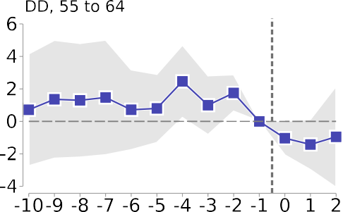
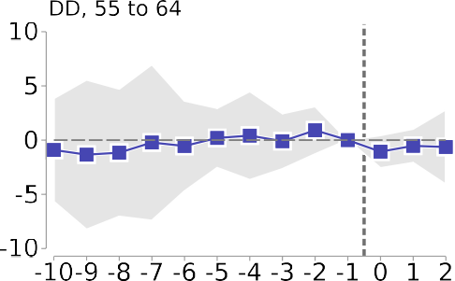
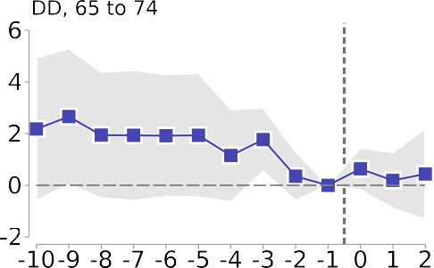
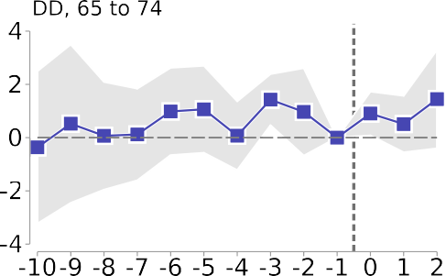
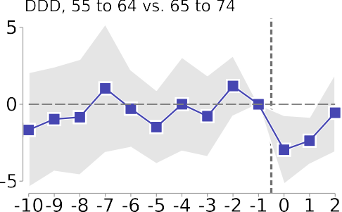
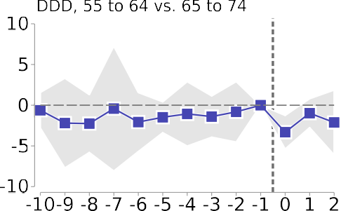

Fig. 1. Event study estimates showing the effect of Medicaid expansion on amenable mortality. Note: Number along the x-axis indicates years since Medicaid expansion. For non-expansion states, t ¼ 0 corresponds to 2014. Years included in this figure are 2004 to 2016. Since each dependent variable is a natural log transform of the healthcare amenable death rate per 100,000, we transform each regression coefficient by 100(exp(coef.)-1) and the standard errors using the delta method. Thus each reported coefficient can be interpreted as the percent effect of Medicaid expansion t years ago on the healthcare amenable mortality rate for a given age group (i.e., a coefficient of -2 would mean a 2% decline in the mortality rate). Point estimates are depicted by blue squares and come from regressions given by Eq. 2 or for an analogous triple difference specification (bottom row). 95% confidence intervals are displayed by gray area and are calculated using robust standard errors clustered at the state level.

but the disadvantage of lacking the same age-groups used in our ACS analysis; there is data for ages 50–64, but not for ages 55–
64. Thus, specifications using the SAHIE data consider those aged 50 to 64 to be treated and only employ our DD design comparing those of similar age in expansion counties to non-expansion counties.
Both the ACS and SAHIE provide additional information on health insurance by race, ethnicity, income, and education. When possible—not all additional information is available for each data source and geography combination—we provide a first stage esti-mate for relevant subgroups as well. We are especially interested in the first stage for low-income individuals as Medicaid eligibility is tied to income.
Table 2 demonstrates our results. Using the ACS data and our DD specifications, we can see that there was a decrease in the unin-surance rate of about 1.75% among those aged 55–64. When using our triple difference specification, the point estimate is quite
similar, showing a 1.6% drop. Estimates using the SAHIE data show somewhat larger first stage estimates for ages 50 to 64 of 2.0% using either state or county-level data. We do not read too much into the difference across these two datasets since the confidence intervals overlap. However, ACA-derived insurance gains could be somewhat smaller among ages 55–64 (on whom we focus) than among younger adults, perhaps because the near-elderly have greater healthcare needs and greater income, which may have led many to obtain insurance before the ACA induced Medicaid expansions. In any case, we use the larger of the estimates, 2.0%, throughout our paper when referring to the first stage for the near elderly.
Demographic characteristics are associated with heterogeneous first stage estimates. Certain groups—non-Hispanic Blacks, Hispan-ics, those without a high school degree, and low-income individu-als—have the largest first-stage estimates. As expected, due to the mechanical nature between income and Medicaid eligibility,

Table 1
The effect of Medicaid expansion on mortality by age group and specification.

 |  |  | State-level |  |  |  |  |  |  | County-level
 | DD 55–64 years |  | DD 65–74 years |  | DDD |  |  | DD 55–64 years |  | DD 65–74 years |  | DDD
(1) |  | (2) | (3) | (4) | (5) | (6) | (7) |  | (8) | (9) | (10) | (11) | (12)
Healthcare amenable mortality  Full expansion dummy -3.23** |  | -2.32** | -1.50 | -0.98 | -1.63 | -0.88 | -0.29 |  | -0.65 | 0.85 | 0.41 | 0.61 | 0.25
(1.27) |  | (1.01) | (1.22) | (0.89) | (1.18) | (0.90) | (2.00) |  | (1.74) | (1.21) | (0.80) | (1.19) | (0.88)
Full expansion dummy x Age 55–64 dummy |  |  |  |  | -1.55**  (0.76) | -1.53*  (0.77) |  |  |  |  |  | -0.83  (0.94) | -0.85  (0.94)
Non-amenable mortality
Full expansion dummy 0.93 |  | 1.45 | 2.95** | 3.32*** | 2.76** | 3.23*** | 3.03 |  | 2.60 | 1.63 | 0.90 | 1.45 | 0.90
(1.36) |  | (1.35) | (1.24) | (0.76) | (1.21) | (0.94) | (2.59) |  | (2.36) | (1.32) | (1.12) | (1.31) | (1.20)
Full expansion dummy x age 55–64 dummy |  |  |  |  | -1.73  (1.11) | -1.73  (1.12) |  |  |  |  |  | 1.56  (1.79) | 1.58  (1.79)
All Mortality
Full expansion dummy -2.27* |  | -1.27 | -0.75 | -0.18 | -0.88 | -0.06 | 0.60 |  | 0.28 | 1.03 | 0.57 | 0.81 | 0.46
(1.18) |  | (0.97) | (1.12) | (0.77) | (1.08) | (0.81) | (1.89) |  | (1.70) | (1.06) | (0.68) | (1.03) | (0.78)
Full expansion dummy x Age 55–64 dummy |  |  |  |  | -1.35*  (0.72) | -1.32*  (0.72) |  |  |  |  |  | -0.17  (1.00) | -0.18  (1.01)
Weights ATTxPop |  | ATTxPop | ATTxPop | ATTxPop | ATTxPop | ATTxPop | ATTxPop |  | ATTxPop | ATTxPop | ATTxPop | ATTxPop | ATTxPop
Unit fixed-effects (state or Yes county)  Year fixed-effects Yes |  | Yes  Yes | Yes  Yes | Yes  Yes | Yes  Yes | Yes  Yes | Yes  Yes |  | Yes  Yes | Yes  Yes | Yes  Yes | Yes  Yes | Yes  Yes
Covariates No |  | Yes | No | Yes | No | Yes | No |  | Yes | No | Yes | No | Yes
Observations 533 |  | 533 | 533 | 533 | 1066 | 1066 | 36478 |  | 36478 | 36478 | 36478 | 72956 | 72956
Note: * p < 0.1, ** p < 0.05, *** p < 0.01. Robust standard errors clustered at the state level in parentheses. Each DD regression corresponds to Eq. 1 while each triple-difference regression corresponds to Eq. 3, with any deviations noted. Years included in this table are 2004 to 2016. Each dependent variable is a natural log transform of the death rate per 100,000 population for the respective group. We transform each regression coefficient by 100(exp(coef.)-1) and the standard errors using the delta method. Thus each reported coefficient can be interpreted as the percent effect of Medicaid expansion on the specific mortality rate for a given age group (i.e., a coefficient of -2 would mean that the relative mortality rate would decrease by 2%). Covariates are used in even-numbered regressions. Third difference (regressions (5)-(6)) is ages 55–64 versus aged 65–74. Covariates include % Medicare Advantage Penetration, % Medicare enrollees receiving social security disability benefits, Per Capita Income, Median Household Income, % Persons in Poverty, Unemployment Rate, 16+, Number of individuals with diabetes as percent of the population, Age-adjusted percent of the population that is physically inactive, Percent of population that is obese, Smoking Prevalence (all genders), and Non-Federal Active MDs per 1000 people.

low-income individuals have the largest first stage estimates–with point estimates indicating an increase in insurance coverage of between 6.7 and 7.3%.¹⁹ Unfortunately, our mortality data do not include income of the decedent. We do however know the race, eth-nicity, and education status of the decedent, which are correlated with income and result in first stage estimates near 4%. This is likely as large a first stage as one can likely achieve without linked individ-ual data on some combination of income, family status (children at home), pre-expansion insurance, and mortality.
Of note, this table uses weights that interact inverse propensity scores with population, so the results are comparable with our mortality regressions. An analogous table using population weights is presented as Table A4 in the Appendix. When weighting only by population, the first stage estimates tend to be slightly smaller than those presented in Table 2.
Our first-stage estimates suggesting that insurance coverage increased by 1.6 to 2% across the entire near elderly population and by around 7% for those under 138% FPL are similar to estimates from recent work. Wehby and Lyu (2018) use ACS microdata from 2011 to 2015 to show that Medicaid expansion caused a 1.6% decline in the uninsurance rate for those aged 56 to 64.²⁰ Courtemanche et al. (2017) use the ACS microdata from 2011 to 2014 to show that Medicaid expansion is associated with a gain in insurance for those aged 50 to 64 of 2.8%. This estimate includes all states and is not limited to full vs. non-expansion states.

¹⁹ This larger increase in insurance coverage for the low income sub-population is particularly salient when displayed in event time as in Appendix Fig. A4.
²⁰ See Table 3 from Wehby and Lyu (2018), which limits the sample of states to full and non-expansion states, the same set of states used in our analyses. When including all states, their estimate rises to 3.5%.
Borgschulte and Vogler (2020) use the SAHIE data and a slightly dif-ferent specification than ours to estimate a 2.7% increase in those with insurance aged 50 to 64. Finally, Miller et al. (2021) demon-strate that for those below 138% FPL or without a high-school degree, Medicaid expansion decreased the uninsurance rate by somewhat more than 4%, which are similar to our estimates for those without a high-school degree and below our estimates for per-sons with income below 138% FPL.
Our first-stage estimates are subject to important limitations. First, survey based estimates of Medicaid enrollment have been shown to severely undercount the percent of true Medicaid enrollees. For example, using the Current Population Survey, Davern et al. (2009) find that many Medicaid enrollees fail to report being enrolled and many report being uninsured. It is possible that newly insured individuals are more susceptible to under-reporting Medicaid enrollment status than those earlier enrolled in Medicaid. Second, many who are eligible for Medi-caid do not sign up until care is needed or are able to sign up retroactively after receiving healthcare (Marton and Yelowitz, 2015). This conditional/retroactive coverage may cause survey based estimates to undercount the share of those who report Medicaid coverage in the ACS.
For both reasons, it is possible that our first-stage is an under-estimate of the true impact of Medicaid expansion on health insur-ance coverage. Thus when considering the mortality effect and the minimum mortality effect that is well powered, we will consider first stages of both 2% (as estimated) and 5%, where the 5% can account for some of these attenuating factors. As outlined in the next section, we will also explore analyses for various subgroups with larger first stages to assess whether these analyses have higher power.

Table 2
The effect of Medicaid expansion on the percentage uninsured by age group and demographics.

ACS (County-level) SAHIE

DD 55–64 DD 65–74 DDD State DD 50–64 County DD 50–64
(1) (2) (3) (4) (5)
All -1.75*** -0.11* -1.60*** -1.97*** -1.99*** (0.30) (0.06) (0.41) (0.34) (0.49)
Female -1.81*** -0.15** -1.59*** -1.99*** -2.11*** (0.39) (0.06) (0.48) (0.41) (0.50)
Male -1.68*** -0.08 -1.63*** -1.93*** -1.89*** (0.25) (0.07) (0.36) (0.29) (0.48)
White (non-Hispanic) -1.57*** -0.03 -1.38*** -1.79*** (0.32) (0.04) (0.41) (0.33)
Black (non-Hispanic) -2.55*** -0.27 -2.64** -2.66*** (0.74) (0.23) (0.99) (0.75)
Other (non-Hispanic) -0.99 -1.06 -1.93
(0.94) (0.74) (1.17)
Hispanic -3.22* 0.34 -4.00** -3.59*** (1.74) (0.54) (1.92) (1.00)
Elementary school -4.40*** -0.96*** -3.55*** (1.05) (0.35) (0.98)
High school incomplete -4.58*** -0.55*** -4.12*** (0.69) (0.20) (0.82)
High school complete -2.03*** 0.03 -2.02*** (0.42) (0.08) (0.54)
Some college -1.32*** -0.05 -1.19*** (0.28) (0.05) (0.35)
Below 138% FPL -7.11*** -0.43* -6.68*** -7.03*** -7.27*** (0.83) (0.23) (1.10) (0.81) (1.33)
138%-400% FPL -1.83*** -0.10 -1.68*** -2.13*** -1.81** (0.44) (0.07) (0.55) (0.47) (0.73)
Observations 369 369 738 451 19628 Unit fixed-effects (state or county) Yes Yes Yes Yes Yes Year fixed-effects Yes Yes Yes Yes Yes
Covariates Yes Yes Yes Yes Yes
Weights used ATTxPop ATTxPop ATTxPop ATTxPop ATTxPop

Note: * p < 0.1, ** p < 0.05, *** p < 0.01. Robust standard errors clustered at the state-level are reported in parentheses. Each estimate comes from a separate regression and the point estimate can be interpreted as the effect of Medicaid expansion on the percent uninsured for a given group (i.e., a coefficient of -2 would mean that the relative percentage of those without insurance in that group decreased by 2 percentage points in full expansion states relative to non-expansion states). ACS data refers to the American Community Survey and are at the county-level covering 2008 to 2016. SAHIE data refers to the Census Bureau’s Small Area Health Insurance Estimates and are reported at both state and county-levels covering 2006 to 2016. See Table A4 in Appendix for similar table with population weights rather than ATTxPop weights.

    - Evidence on Heterogeneous Effects
We conduct additional analyses of the effects of ACA-induced insurance variation on mortality, focusing on vulnerable subgroups or particular causes of death. These subgroups can potentially pro-vide a stronger first stage, a stronger second stage, or both, which can increase power. However, moving to subgroup analysis also reduces the population composing each subgroup in each county or state, which increases the annual mortality rate variance and will reduce power, all other things equal. We consider subgroups based on gender, race/ethnicity, and specific cause of death. We present these results in the Appendix Table A3.
At the county level, evidence of a statistically significant effect of Medicaid expansion on mortality for particular subgroups proves to be largely absent; we find statistically significant results for two of thirteen DD coefficients and one of thirteen triple differ-ence coefficients. As with our full-sample results, we find stronger evidence for mortality effects when using state-level data—in par-ticular, for respiratory mortality and mortality for men. We do find strong and statistically significant effects for Black mortality across both the county and state aggregates for both DD and triple differ-ence designs; estimates suggest that Medicaid expansion induced reductions in Black population mortality of between 3.7 and 8.6 percent. In the next section, we explore how these larger treatment effects and larger first stage estimates affect statistical power.

- Simulated Power Analysis

We conduct a simulation-based power analysis by artificially introducing treatment effects of different sizes into the data in
the pre-treatment period, and then assessing (over many itera-tions) how often our specifications can detect these effects. The goal of this analysis is to determine the minimum effect of health insurance on amenable mortality that is reliably detectable with our data and research design. The alternative of a closed-form power analysis requires fully modeling the data generating pro-cess, including parameterizing the error term for both variance and covariance terms, and is especially hard to construct with panel data in which observations can be correlated over time (Burlig et al., 2020). Our use of regression weights and clustered standard errors further contributes to the difficulty in producing a tractable and credible form for an analytic power calculation.
Simulation avoids these challenges and lets us use the same research design and econometric specification as the main analy-sis. In our preferred simulations, we perturb real, but untreated data. Our simulation approach mechanically builds in correlations and ‘‘noise” from trends in the actual data. A simulation using entirely artificial data would have similar conceptual issues as the closed form analyses, requiring modeling the level and form of trends and correlations in the data.²¹
Our preferred simulation proceeds as follows. We use only data from the pre-treatment period to ensure that it is not possible for any treatment effect to influence our results. We maintain the same basic structure in our power analysis as in our earlier analy-sis: using ten years of ‘‘pre-treatment data” (from 2001 to 2010 instead of 2004 to 2013) and three years of ‘‘post-treatment data”

²¹ We do explore some simulations that use artificial data. These results are presented in Table 3.

(from 2011 to 2013 instead of 2014 to 2016), where a pseudo treat-ment is assigned in 2011. We restrict the sample of states to be the same ones used in our earlier analysis (i.e., the 41 full-expansion and non-expansion states).
We next repeat the following 1,000 times: randomly assign a pseudo-expansion status to 22 of the 41 states, to match the num-ber of full-expansion states. We assume that expansion occurred in 2011, giving us ten years of pseudo pre-treatment and three pseudo post-treatment years. This ensures that there are always the same number of pseudo control state-years and pseudo treated state-years in our power analysis as in our earlier specifications.
For each randomly drawn set of pseudo-treated states, we impose a pseudo treatment effect by reducing amenable mortality (from 0% to 8%, in 0.25% increments) for all persons aged 55–64 liv-ing in a pseudo-treated state. We do this by randomly removing deaths from each pseudo-treated county-year (or state-year) using draws from a binomial distribution. For example, if a county-year has 100 healthcare-amenable deaths and the imposed treatment effect is 0.5%, we remove each death with probability 0.005. The expected number of remaining deaths is then 99.5, but the actual number must be a whole number and could be 100, 99, 98, etc. As in this example, it is unlikely that any pseudo-treated county will have its mortality rate decrease by exactly 0.5%, but the pseudo-treated counties will still experience the imposed treat-ment effect on average.²²
We opt for this approach since it ensures that each simulated dataset used in our power analysis resembles data that could actu-ally occur. Consider the alternative of reducing the death rate in each county by the imposed treatment effect. This would enforce an identical treatment effect across all treated units and produce negative death rates in some units.
Within each iteration, we re-estimate the inverse propensity score based weights so that after re-weighting, the pseudo-control states match the pseudo-treated states. We then run the DD model in Eq. 1 and save the regression coefficient and standard error. For a given imposed effect size and significance level, the percentage of times a result is found to be statistically significant equals the power. For each specification, we report the smallest imposed effect size that can be detected at the 5% significance level with 80% power—an arbitrary, but common threshold used to denote ‘‘adequate power.” We use a similar method to assess power using the triple difference model in Eq. 3.
In addition to statistical power, we also report three measures based upon Gelman and Carlin (2014) that inform the plausibility of any statistically significant results obtained, given the underly-ing power of the study: 1) the percentage of times a statistically significant, estimated treatment effect has the wrong sign—i.e., the opposite sign as the imposed treatment effect; 2) for the subset of cases where a statistically significant effect is found, the mean ratio of the estimated treatment effect to the true, imposed effect (i.e., the exaggeration ratio); and 3) the percentage of statistically significant treatment effect estimates that have both the correct sign and an exaggeration ratio below two—which we term a ‘‘be-lievable” coefficient.
Our empirical specifications (Eqs. 1 and 3) and accompanying power simulations require a number of choices: for example, which, if any, weights to be used; the level of clustering for stan-dard errors; the inclusion of control variables; the length of the

²² When we impose zero treatment effect, the measured effects across many draws of pseudo-treated counties (or states) will form a distribution centered at zero. Similarly, when we impose a specific effect (e.g., x%), the measured effects across many draws will form a distribution centered at an x% treatment effect. This is because we are adding the imposed effect to the existing data. If we were to use data from the treated time period, we would first need to ‘‘enforce the null” before imposing our effect size. We prefer not to follow this approach because it is unclear how best to enforce the null before adding in an imposed treatment effect.
pre-treatment period; the level of the analysis (e.g., county-year vs. state-year); whether or not to include data from the post-treatment period in the power simulation; and the use of per-turbed—but real data—vs. entirely artificial data in the power sim-ulation. It is important to understand how these choices affect power and our estimate of the minimum detectable effect size. We therefore repeat our power simulation after altering each of these choices, reporting the minimum effect size that is detectable at the 5% significance level with 80% power for each.
Finally, power is affected by the proportion of the population who experienced an insurance expansion. Medicaid expansion tar-geted lower-income individuals and an analysis solely focused on subgroups more likely to be treated could potentially have more power than a whole group analysis, depending on the trade-off between a larger first stage and a smaller sample. While our mor-tality data do not report income, the data do report other demo-graphic information that is correlated with Medicaid eligibility and thus with a larger first stage. The data also report cause of death and it is possible that individuals with certain ailments (e.g., cancer) would disproportionately benefit from Medicaid enrollment, which would improve power. We explore power for subgroups defined by demographics or cause of death in Section 4.3.

  - Full Sample Power Simulation

Fig. 2 illustrates the results from our full sample power simula-tions, using log amenable mortality rate per 100,000 as the depen-dent variable. Each simulation uses actual data from 2001–2013 for treated and control states. We apply an imposed treatment effect of gradually increasing magnitude to 22 states chosen at ran-dom for 2011 to 2013. For a pseudo-shock of a given size, power is defined as the percent of the 1,000 simulations that result in a sta-tistically significant pseudo-treatment effect at a given significance level. We display results for the 10%, 5%, 1% and 0.1% significance levels.
The left panel shows simulation results using state-level data, while the right shows simulation results using county-level data. The top row shows DD results that correspond to Eq. 1 and the bot-tom row shows triple-difference results that correspond to Eq. 3. For example, if we impose an effect of 1.53% using the triple differ-ence specification and state-level data (compare to column 6 from Table 1), 51.2% of the 1000 simulations find a statistically signifi-cant effect at the 5% level. Fig. 2 also reports the estimated MDE and the 95% CI for the MDE. The MDE at the state (county) level is 2.55% (2.88%) for the DD specification and 2.17% (2.33%) for the triple-difference specification.
For our triple difference specification, we depict believability measures adapted from Gelman and Carlin (2014) in Fig. 3. Panel A shows the ratio of the magnitude of the estimated effect—when found to be statistically significant—to the true imposed effect. For effect sizes under 1%, the exaggeration ratio is high. That is, an effect large enough to be statistically significant is likely to be two or more times larger than the true effect. In Panel B we show the proportion of statistically significant results that have the wrong sign. This proportion is also appreciable for the smaller imposed effect sizes, reaching almost 10%. As we increase the imposed effect size, prevalence of sign-error shrinks, becoming negligible for effect sizes above 1%; the exaggeration ratio also shrinks, but more slowly. We combine these two measures in Panel C, which reports the percentage of statistically significant esti-mates that are ‘‘believable” (correct sign and magnitude error no greater than two). The believability percentages follow the power curves from Fig. 2 quite closely. Thus loosely speaking, power is also informative for the proportion of statistically significant esti-mates that are believable.

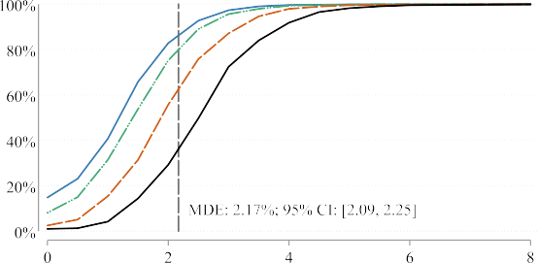
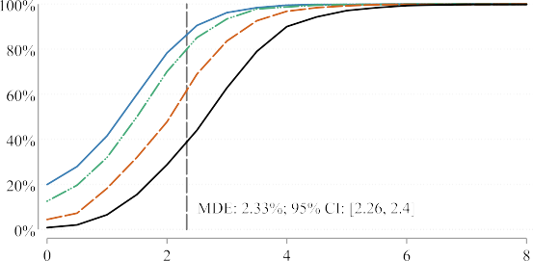
Fig. 2. Power simulation results. Note: Each sub-figure represents results from 1000 simulations as outlined in the text. Broadly, each simulation uses actual data from 2001–2013 from our actual treated and control states; we impose a pseudo-shock of gradually increasing magnitude to 22 pseudo-treated states chosen at random for 2011 to 2013; and for a pseudo-shock of a given size, power equals the percent of the simulations that result in a statistically significant pseudo-treatment effect at a given significance level. Results for the 10% significance level are displayed by the solid blue line; results for the 5% significance level by the dashed green line; 1% significance level estimates by the dashed orange line; and for the 0.1% significance level by the solid black line. MDE (minimum detectable effect) is the smallest imposed treatment effect that is detectable with 80% power at the 5% significance level. The 95% confidence interval for the MDE is estimated through a bootstrapping procedure. The left column presents results using state-level data, while the right column presents results using county-level data. The DD results correspond to Eq. 1, while the triple difference results correspond to Eq. 3.

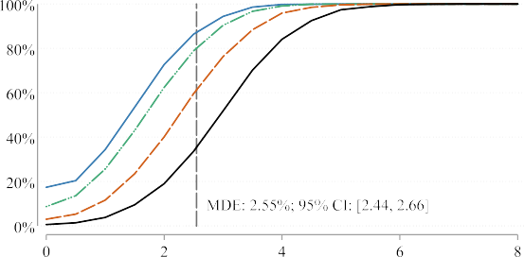
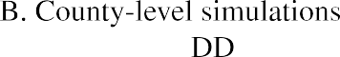
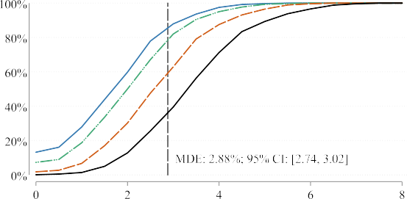
As outlined earlier, our research design choices may affect power and thus our minimum detectable effect estimates. Table 3 demonstrates the sensitivity of MDE estimates to those choices. For each MDE estimate, we report 95% confidence intervals that are computed using 1,000 bootstrapped draws from the 1,000 power simulations. Column (1) represents our preferred estimates: ATT population weights; clustering standard errors at the state level; controlling for other county-year variables; using data from the pre-treatment period; with 2001–2010 as the pseudo pre-treatment period; an with 2011–2012 as the pseudo post-treatment period.
x
The top panel presents simulation results using state-level data and the bottom panel presents analogous results at the county-level. Columns (1) through (6) all are power simulations that only use pre-Medicaid expansion data. In each column, we vary at least one feature from our preferred simulation, including: level of clus-tering (county or state), weights (ATT population or population), pre-period length (2001–2010, 2004–2010, or 2007–2010), and whether or not control variables are included. Columns (7) and
x
(8) use the actual Medicaid expansion period as the treatment per-iod, but only data from non-expansion states. Column (7) excludes data from expansion states and resamples from the twenty-two control (i.e., non-expansion) states so that in each draw 41 total
states are selected with 19 serving as pseudo treated and 22 serv-ing as pseudo control. Column (8) uses the same data as in our main simulations, except for the dependent variable. The depen-dent variable is artificial and is constructed such that each county-year death rate is a draw from a normal distribution with the same mean and variance as that each county’s actual mean death rate from 2001 to 2013. We also impose on the artificial data a linear time trend based on the observed mortality data (see Fig. A1). We do this by regressing a simple time trend on the mor-tality data in the pseudo pre-treatment period and assuming that this time trend continues into the pseudo post-treatment period.
Most of these simulations yield similar minimum detectable estimates, indicating that our preferred specification choices do not drive our MDE estimates. The majority of MDEs are just above 2%; the triple difference specifications have smaller minimum detectable effect sizes; and controlling for covariates improves power. Triple-difference MDEs are somewhat smaller with popula-tion weights that with ATT population weights. However, these specifications are problematic as they exhibit pre-trends when analyzed in event-time.
x
There could be a trade-off between identification (or a preferred specification) and the power of an estimate. For our analysis, we aim to first determine which specifications are reasonable and

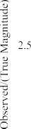
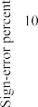
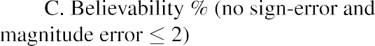

Fig. 3. As power increases so does believability (i.e., reduced magnitude error and chance of sign-error). Note: Results here correspond to power simulations at state-level for the triple difference specification (the bottom right sub-figure from Fig. 2). Each sub-figure presents a different measurement in addition to power. Magnitude-error is depicted in sub-figure A, which is the average of the statistically significant estimate divided by the true effect size. Sign-error is depicted in sub-figure B, which is the percent of times a statistically significant estimate has a different sign that the imposed treatment effect. Believability combines these two concepts and shows the percent of simulations that report a statistically significant estimate without a sign-error or magnitude error. Line shapes and colors are the same as in Fig. 2. MDE and 95% confidence interval are the same as the underlying specification in Fig. 2.

most likely to be well identified before we turn to concerns of power. An unidentified, may be uninterpretable, even if better powered. Therefore we prefer the slightly lower powered, but bet-ter identified estimates that use inverse propensity score weights. We obtain substantially lower MDEs in column (7) by using state-level data that includes the actual treatment period, but only for non-expansion states. We view these as unreliable because draw-ing 41 pseudo states with replacement from 22 actual non-expansion states may understate the true variability of mortality in the full sample, including the expansion states.
The largest minimum detectable effect sizes come from the specifications that use artificial death data. This is likely because these artificial data are not able to take advantage of the power gains from including covariates and county (or state) and year fixed-effects. One could imagine simulating artificial data that is micromanaged and tweaked to increase power, but it would be unclear why these results would be more believable than those using real data.
Overall, we view the MDE robustness analysis in Table 3 as con-firming the importance of the specification and sample choices that must be made in a power analysis and the need to assess the robustness of estimates to alternative choices, just as one would routinely assess robustness of other results to specification and sample choices.
  - Interpretation of results

Comparing the minimum detectable effect size to the estimated first stage (i.e., the % increase in insured status due to Medicaid expansion) is a natural way to examine the plausibility of any treatment effect estimate. For example, if one compares the 2% first stage from Table 1 to the MDEs from our preferred specifications (2.17%), a well-powered result appears unrealistic. This would imply that Medicaid expansion would have to reduce the average amenable mortality rate of all newly insured persons by over 100%. However, this comparison bakes in the assumption that the average mortality rate for the newly Medicaid-insured is the same as for other persons aged 55–64, which need not be the case. The mortality rate for the compliers among the newly insured (those who will gain insurance only if they live in an expansion state) could be either higher or lower than the average for all per-sons. For example, the newly Medicaid insured tend to be low income, and thus may have higher mortality. On the other hand, the disabled are already insured and those in poor health could be more likely to already have insurance. The sign and extent of differential mortality for the compliers is an empirical question, on which prior research provides mixed evidence. Kowalski (2020) provides evidence for the Massachusetts insurance expan-sion in 2006 that complier populations can be of better health rel-

Table 3
Illustrating how the minimum detectable effect size varies with specification and other choices made in the power simulation.

(1) (2) (3) (4) (5) (6) (7) (8)

Simulations using only pre-expansion data Simulations including post-expansion data
 |  |  |  |  |  |  | Non-expansion states  only | Using artificial death  data
State-level
MDE, DD 55–64 | 2.55 | 2.27 | 1.92 | 3.43 | 2.36 |  | 1.17 | 2.15
 | (2.44 to | (2.21 to | (1.81 to | (3.30 to | (2.30 to |  | (1.11 to 1.24) | (2.00 to 2.29)
 | 2.66) | 2.33) | 2.03) | 3.56) | 2.43)
MDE, DDD | 2.17 | 2.04 | 1.79 | 2.18 | 1.77 |  | 1.26 | 5.28
 | (2.09 to | (1.94 to | (1.73 to | (2.11 to | (1.73 to |  | (1.21 to 1.32) | (5.11 to 5.45)
 | 2.25) | 2.13) | 1.85) | 2.26) | 1.81)
County-level
MDE, DD 55–64 | 2.88 | 2.79 | 2.36 | 4.23 | 2.28 | 2.39 | 1.82 | 5.29
 | (2.74 to | (2.70 to | (2.23 to | (4.08 to | (2.21 to | (2.24 to | (1.72 to 1.92) | (4.70 to 5.88)
 | 3.02) | 2.87) | 2.50) | 4.38) | 2.34) | 2.53)
MDE, DDD | 2.33 | 2.21 | 2.07 | 2.36 | 1.75 | 2.23 | 1.37 | 9.77
 | (2.26 to | (2.13 to | (1.99 to | (2.29 to | (1.70 to | (2.15 to | (1.25 to 1.50) | (9.01 to 10.53)
 | 2.40) | 2.29) | 2.16) | 2.44) | 1.80) | 2.31)
Weights | ATTxPop | ATTxPop | ATTxPop | ATTxPop | Pop | ATTxPop | ATTxPop | ATTxPop
Clustering | State | State | State | State | State | County | State | State
Controls | Yes | Yes | Yes | No | Yes | Yes | Yes | No
Pre-treatment | 2001–2010 | 2004–2010 | 2007–2010 | 2001–2010 | 2001–2010 | 2001–2010 | 2001–2013 | 2001–2013
years  Post-treatment | 2011–2013 | 2011–2013 | 2011–2013 | 2011–2013 | 2011–2013 | 2011–2013 | 2014–2016 | 2014–2016
years
Note: Each MDE estimate and 95% confidence interval comes from a separate power simulation. The top set of results use state-level data. The bottom set use county-level data. The DD specifications are similar to Eq. 1 and the triple difference specifications are similar to Eq. 3. Differences from these specifications are noted in each column. 95% confidence intervals in parentheses are calculated using 1,000 bootstrap draws.

ative to comparison populations. Finkelstein et al. (2012) study a lower-income, likely less-healthy population (persons who applied for the Oregon Medicaid expansion lottery), and report annual total mortality for the controls (those who did not win the lottery) of 0.008, which is similar to the average total mortality rate we find for persons aged 55–64 in both full-expansion and non-expansion States (see Table A2).
Conversely, Chetty et al. (2016) demonstrate a strong link between income and life-expectancy (where income is directly tied to Medicaid eligibility). Miller et al. (2021) use data from the National Health Interview to establish that Medicaid enrollees aged 55–64 in 2014 have a 2.3% probability of death in the next year, higher than the cohort average of 1.4%. Finally, Marton and Yelowitz (2015) provide evidence that conditional coverage, in which, people wait to sign up for Medicaid until they are sick, or hospitals can arrange for retroactive coverage. This would both increase mortality rates for actual recent Medicaid enrollees, rela-tive to all previously uninsured persons and imply that our first-stage estimates are downward biased.
Having a clear understanding of how much more likely the compliers are to die relative to the general population of 55–64 year olds is crucial to understanding whether plausible treat-ment effects are comparable in magnitude to our MDE estimates. For example, if the mortality rate of the 55 to 64 year olds who gained insurance due to Medicaid expansions was twice that of the general population of 55 to 64 year olds, then the estimated treatment effect on the treated would drop from 109% to 58%. Since we cannot determine the ratio of complier to full population mor-tality with certainty, we present a range of potential treatment on the treated estimates that correspond with different mortality ratios in Fig. 4. With a 2% first stage to obtain a treatment on the treated of 30% or less the compliers would have to be at least 3.8 times more likely to die than the general population without insur-ance. With a 5% first stage, this ratio would need to be 1.7 or greater to obtain a treatment on the treated of 30% or less.
Thus for our study to have adequate power to detect treatment on the treated (TOT) effects of plausible magnitude, at least one of two things must be true. First, the compliers could be substantially more likely to die than the general population. Second, the true first stage could be much larger than the estimated first stage of 2%.

  - Power for vulnerable subgroups

We also conduct power analyses in which we estimate the MDE for subgroups based on different demographics, education levels, and causes of death. We assess for these subgroups whether a higher first-stage or a larger treatment effect could lead to improved power. Table 2 demonstrates that many of these sub-groups have larger first stage estimates than the overall population (e.g., Blacks aged 55–64 saw increases in insurance of around 2.6% in expansion states, Hispanics saw increases of 3.2 to 4%, and those who had not completed high-school saw increases of around 4.5%). We also estimate the MDE for specific causes of death (cancer, HIV, diabetes, cardiac, and respiratory ailments) for which health insur-ance may be especially important for access to healthcare (e.g. can-cer through chemo-therapies).
We do not find, however, lower MDEs for any of these sub-groups. Fig. 5 displays results. We show results at both the state level (Panel A) and the country level (Panel B), for both DD (left-column) and triple-difference (right-column) analyses. We con-struct each MDE estimate following the same procedure as for the full specifications. Across all specifications, the subgroup MDEs are larger than the comparable full-sample MDE.
In the top row of each panel, we plot the MDEs for each subsam-ple against the first stage for subgroups based on demographics and education (we cannot compute the first-stage for cause of death) together with a regression line showing the correlation between the two. The shaded areas show the 95% confidence interval for each regression line. There is a clear, positive relation-ship: subgroups with larger first stages have higher MDEs.

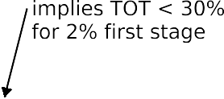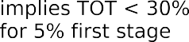
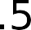

Fig. 4. For a given average population treatment effect, the implied treatment on the treated (TOT) decreases as the mortality ratio of the compliers to the full population increases or a larger share of the population gains insurance due to Medicaid expansion. Note: The thick orange line represents the relationship between the implied treatment on the treated and the mortality ratio of the compliers relative to the full population for a 2% first stage. The dashed black line represents the same relationship for a 5% first stage. Both consider an average treatment effect size of 2.17%, which is the MDE for the state-level triple difference research design.

The natural explanation, which we confirm in the middle row, is that mortality rates for these subgroups are less precisely esti-mated, which more than offsets the gain in power from a higher first stage. In the middle row, we plot each subgroup the MDE against the coefficient of variation (the average standard deviation across geographic units compared to the mean). We use the coeffi-cient of variation as a simple measure of noise in the subgroup mortality rate. This is why average power among the subgroups is worse than when all groups are combined; breaking into sub-groups increases noise in each group.
Finally, the bottom row compares the MDE to the coefficient of variation, and includes subgroups based on cause of death. Higher volatility is associated with a larger MDE. Thus, in our setting we cannot improve power by focusing on smaller subgroups who may benefit more from health insurance, since higher subgroup volatility in county-level mortality rate dominates the increased first stage and potentially larger treatment effect.

  - What data would be needed for reasonable power?

We turn in this section to a different question—what combina-tion of a stronger first stage and a reduction in amenable mortality for the newly insured would be detectable with reasonable power, if we could use a richer dataset, with data on mortality linked to data on income and family status (to determine eligibility for Med-icaid) and pre-ACA insurance status (to exclude the always-insured from the sample)?.
These hypothetical data are similar to those used in recent work by Miller et al. (2021) and Goldin et al. (2021). One could improve the first stage to 7% by studying only adults with incomes 6138% of FPL and one could reach almost 10% as in Simon et al. (2017) by focusing on childless adults with incomes 6 100% of FPLs. In these
analyses, we consider the triple-difference design, which has higher power in our setting.
In this scenario, we imagine that we can identify in each county both a treated subsample and a similar within-county control subsample, both aged 55–64. For example, if the treated subsample is childless adults with income 6138% of FPL, the within county control subsample could be childless adults with incomes from 138% to 250% of FPL. We assume hypothetical first stages varying from 2% to 20% and hypothetical second stages varying from 0% to 4%. For, say, a 5% first stage and a 2% second stage, we assign ‘‘insurance due to Medicaid expansion” to 5% of the persons in the treated group of each expansion county, and then remove 2% of the amenable mortality deaths from these persons (thus applying an overall mortality reduction to the sub-sample of.002). We again use data from 2001 to 2013 and a pseudo-treatment beginning in 2011, and assess whether we could detect this mortality effect if we did not know which specific individuals within this subsample gained insurance due to this pseudo-treatment. Since the treated and control samples are drawn at random from the same county and age range, they have the same expected mortality rates, absent pseudo treat-ment, by construction.
In Fig. 6, we show power curves only for the 5% significance
level. We vary (i) the assumed first stage (we show curves for 2%, 3%, 5%, 10%, and 20% first stages) and (ii) the imposed mortality reduction for the newly insured (from 0% to 4%). With this hypo-thetical richer data, we need a smaller number of avoided deaths to be able to reliably detect a treatment effect. For example, with a 10% first stage, we could reliably detect mortality reductions of 0.95% or more for the newly insured. This shows that individual level data with known treatment status can improve power, and highlights the value of studies that use such data (Miller et al., 2021; Goldin et al., 2021).

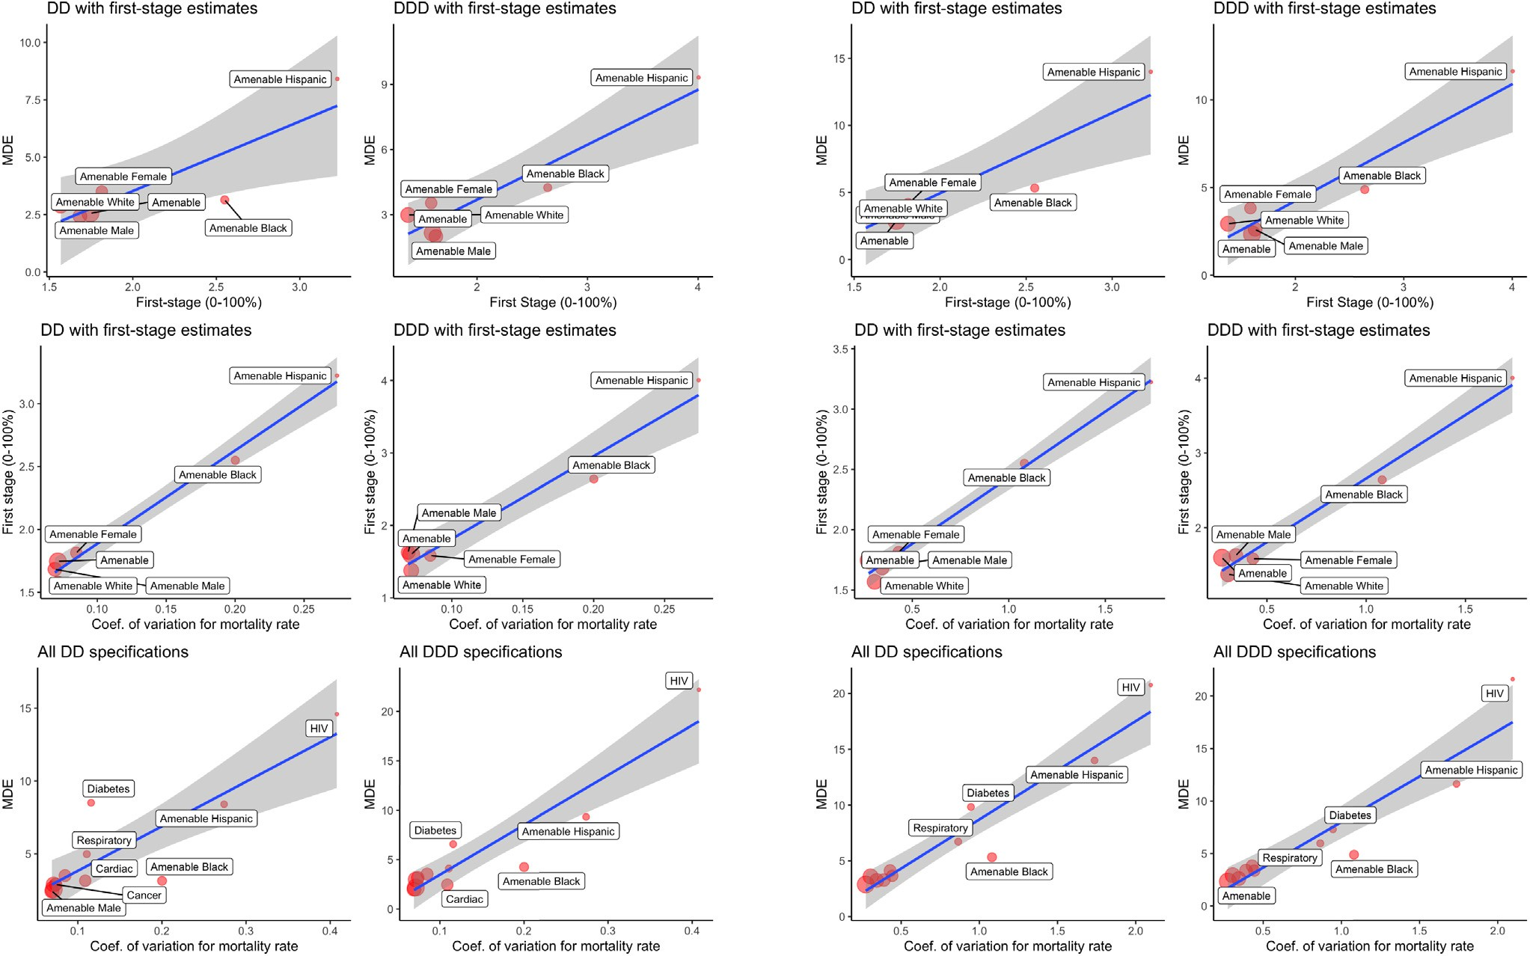

Fig. 5. Aspects of power for sub-groups. In our setting, sub-groups with larger first-stages have higher MDEs because sub-groups tend to have more volatile mortality rates. Note: Panel A presents simulation results using state-level data. Panel B presents simulation results using county-level data. The top row plots the minimum detectable effect (MDE) for each subgroup against the first stage estimate. The middle row plots the first-stage against a measure of variance (the coefficient of variation for mortality rate). The bottom row compares the MDE to the coefficient of variation. Each plot includes a regression line; the shaded area shows the 95% confidence interval.
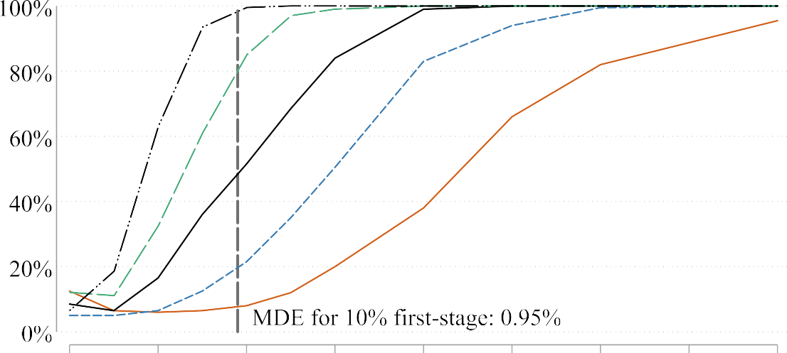

Fig. 6. Additional data on treatment status can greatly reduce minimum detectable effect size.

- Conclusion

In this manuscript, we advocate greater use of power analyses in observational studies and we explore issues of statistical power using an applied example: the relationship between mortality and health insurance. We focus on whether or not true effects can be reliably detected using geographically aggregated data. Using county-level data, we find no statistically significant evidence of an ACA-induced decline in mortality in Medicaid expansion states, but with state-level data estimates show that healthcare-amenable mortality declined for the near elderly by 1.53%. Using simulated power analyses, we show that our research designs would need to find at least a 2.17% effect to be well powered; when the true effect is 1.53%, statistical power is just above 50%. We discuss the first stage (the percent of near elderly gaining insurance due to Medicaid expansion), the mortality rate, and assumptions needed to interpret the treatment-effect-on-the-treated.
Power is an important metric that can be used to evaluate the credibility of an empirical result, as to both magnitude and sign. However, power is rarely reported in empirical work. Studies with low statistical power will often fail to reject the null hypothesis even when a true effect with an economically important magni-tude exists. Conditional on finding a statistically significant effect, low-powered estimates can substantially overstate the magnitude of the true treatment effect and can generate the wrong sign. A combined measure of ‘‘believability” (correct sign and magnitude no larger than twice the truth) is closely related to power and is low when power is low.
One impediment to conducting power analyses in observational studies is the lack of closed form power formulas for many com-mon research designs. Here we present a simple method of esti-mating power using simulation applied to actual data. While we are not the first to estimate power using simulation, we take very seriously the actual impediments a modern researcher faces. There is no uniform approach that will work to estimate power in every setting. Each project will face its own idiosyncratic choices and trade-offs. In this regard, we attempt to outline common issues that other researchers may face when seeking to conduct their own simulated power analyses.
Declaration of Competing Interest

The authors declare that they have no known competing finan-cial interests or personal relationships that could have appeared to influence the work reported in this paper.

Appendix A. Appendix

Table A1 includes Medicaid expansions through 2016. It is based on combining and reconciling the classification of states as ‘‘full expansion,” ‘‘None,” or in- between (‘‘mild” or ‘‘substantial” expan-sion), by Simon et al. (2017),Lou et al. (2018), and Kaiser Family Foundation (2018). Most states could be classified based on their rules for when and to what level they expanded Medicaid for all adults. Arizona required special care; see detailed analysis below. Because our mortality data are annual, we consider New Hamp-shire to be a 2015 expansion, Alaska to be a 2016 expansion, and Louisiana to be a 2017 expansion, hence beyond our study period. In the expansion details column, ACA Expansion means regular expansion to 138% of FPL, on the date stated in the Effective Date column. In the inclusion/exclusion column, C = control (non-expansion), T = treatment (full expansion), and other states are excluded. Simon et al. (2017) classify early expansion states as mild or substantial expansion, based on their assessment of the extent to which enrollment increased with full Affordable Care Act expansion in 2014. This classification of states based on expan-sion status is also used in our manuscript (referred to as BHNS). % change in uninsured enrollees (2013–20156) come from SAHIE estimates for ages 18–64 and considering all income groups.
Fig. A1,A2,A3,A4,A5,A6,A7,A8
Tables A2, A3, A4, A5.

Appendix B. Supplementary material

Supplementary data associated with this article can be found, in the online version, at https://doi.org/10.1016/j.jpubeco.2022. 104713.

Table A1
Medicaid expansion states: part 1.

State | Abbr. | Expansion Details | Effective | % change in uninsured | Inclusion/ | Expansion | Compare to BHNS
 |  |  | Date | enrollees (2013–2016) | Exclusion | type
Alabama AL None -5.3 C [.] None Consistent
Alaska AK Medicaid Expansion 9/1/15 -6.9 T [2016] Full Consistent for 2014–2015
(expanded late 2015)

Arizona[1] AZ § 1115 Waiver (100% FPL, but closed to
new enrollees in 2011)
2000 -9.1 T[2014] Full Consistent

ACA Expansion 1/1/14
Arkansas[2] AR § 1115 Waiver 1/1/14 -10.8 T [2014] Full Consistent
Private Option
California[3] CA § 1115 Waiver (LA county) 1/1/95 -12.8 Excluded Substantial Consistent
§ 1115 Waiver (200% FPL) 11/1/10 (Early expansion)
ACA Expansion 1/1/14
Colorado[4] CO § 1115 Waiver (to 10% of FPL) 4/1/12 -7.2 T [2014] Full Consistent ACA Expansion 1/1/14

Connecticut [5]
CT State Plan Amendment (56% FPL) 4/1/10 -5.7 Excluded Substantial Consistent

ACA Expansion 1/1/14 (Early Expansion)

Delaware[6] DE ACA Expansion 1/1/96 -5.8 Excluded Mild Consistent
1/1/14 (Early
Expansion)

District of Columbia [7]
DC State Plan Amendment (133% FPL) 7/1/10 -3.4 Excluded Mild Consistent

§ 1115 Waiver 12/1/10 (Early expansion)

ACA Expansion 1/1/14
Florida FL None -9.5 C [.] None Consistent
Georgia GA None -7.0 C [.] None Consistent Hawaii[8] HI ACA Expansion 8/1/94 -4.5 Excluded Substantial Consistent
1/1/14 (Early
expansion)
Idaho ID None -7.8 C [.] None Consistent Illinois IL ACA Expansion 1/1/14 -8.4 T [2014] Full Consistent Indiana IN § 1115 Waiver 2/1/15 -8.1 T [2015] Full Consistent Iowa[9] IA § 1115 Waiver 1/1/14 -6.2 T [2014] Full Consistent Kansas KS None -5.6 C [.] None Consistent Kentucky KY ACA Expansion 1/1/14 -12.9 T [2014] Full Consistent Louisiana LA ACA Expansion 7/1/16 -9.1 C [.] None Consistent Maine ME None -4.4 C [.] None Consistent Maryland MD ACA Expansion 1/1/14 -5.2 T [2014] Full Consistent
Table A1: Medicaid expansion states, part 2

State Abbr. Expansion Details Effective Date
% change in uninsured enrollees (2013–2016)
Inclusion/ Exclusion
Expansion type
Compare to BHNS

Massachusetts [10]
MA ”Romneycare” 4/12/06 -1.7 Excluded Mild Consistent

ACA Expansion 1/1/14

Michigan MI ACA Expansion 4/1/14 -7.9 T [2014] Full Consistent

Minnesota [11]
MN State Plan Amendment (75% FPL) 3/1/10 -4.6 Excluded Substantial Consistent

§ 1115 Waiver (200% FPL) 8/1/10 (Early Expansion)

ACA Expansion 1/1/14
Mississippi MS None -6.5 C [.] None Consistent

Missouri MO § 1115 Waiver (St. Louis County Only) (200% FPL)
None
7/1/12 -4.9 C [.] None Consistent

Montana MT ACA Expansion 1/1/16 -10.7 T [2016] Full Consistent for 2014–2015
(expanded in 2016)
Nebraska NE None -2.3 C [.] None Consistent Nevada NV ACA Expansion 1/1/14 -11.3 T [2014] Full Consistent

New
Hampshire [12]
NH § 1115 Waiver 8/15/14 -6.3 T [2015] Full Consistent (expanded late
2014)

New Jersey [13]
NJ § 1115 Waiver (23% FPL) 4/1/11 -7.2 T [2014] Full Consistent ACA Expansion 1/1/14

New Mexico NM ACA Expansion 1/1/14 -14.5 T [2014] Full Consistent New York[14] NY § 1115 waiver 10/1/01 -6.1 Excluded Mild Consistent
ACA Expansion 1/1/14 (Early expansion)

Table A1 (continued)
State Abbr. Expansion Details Effective Date

% change in uninsured enrollees (2013–2016)

Inclusion/ Exclusion

Expansion type

Compare to BHNS

North
Carolina
NC None -6.4 C [.] None Consistent

North Dakota ND ACA Expansion 1/1/14 -4.4 T [2014] Full Consistent Ohio OH ACA Expansion 1/1/14 -7.6 T [2014] Full Consistent Oklahoma OK None -4.5 C [.] None Consistent

Oregon OR [15]
ACA Expansion 1/1/14 -11.1 T [2014] Full Consistent

Table A1: Medicaid expansion states, part 3
State Abbr. Expansion Details Effective Date

% change in uninsured enrollees (2013–2016)

Inclusion/ Exclusion

Expansion type

Compare to BHNS

Pennsylvania PA ACA Expansion 1/1/15 -5.3 T [2015] Full Consistent Rhode Island RI ACA Expansion 1/1/14 -9.1 T [2014] Full Consistent South Carolina SC None -7.2 C [.] None Consistent
South Dakota SD None -4.4 C [.] None Consistent
Tennessee TN None -6.1 C [.] None Consistent
Texas TX None -6.4 C [.] None Consistent
Utah UT None -6.1 C [.] None Consistent

Vermont VT [16]
§ 1115 Waiver 1/1/96 -5.0 Excluded Mild Consistent

ACA Expansion 1/1/14 (Early expansion)

Virginia VA None -4.3 C [.] None Consistent

Washington [17]
WA § 1115 Waiver (133% FPL) 1/3/11 -10.3 T [2014] Full Consistent

ACA Expansion 1/1/14

West Virginia WV ACA Expansion 1/1/14 -12.0 T [2014] Full Consistent

Wisconsin[18] WI New eligibility for BadgerCare but not ACA Expansion
2009 -5.2 Excluded Substantial Consistent

Wyoming WY None -2.5 C [.] None Consistent

Notes: [1] Arizona used a § 1115 waiver to expand Medicaid coverage to childless adults up to 100% FPL during 2000–2011. In 2011, the state started to phase out that program (transitioning into Medicaid expansion). Which category Arizona belongs in was unclear based on its rules, so we also examined the extent to which Medicaid enrollment increased in 2014. See details below. [2] Arkansas operated a limited-benefit premium-assistance program for childless adults who worked for small uninsured employers (ARHealthNetworks waiver) prior to the ACA. Arkansas’s Medicaid expansion includes a ”private option” under which Medicaid-eligible persons receive health insurance from the state insurance exchange, with a small monthly premium. [3] California expanded Medicaid in 2010–2011, in selected counties. [4] Colorado conducted early expansion through a § 1115 waiver in 2012, but only to persons with income < 10 (ten) % of FPL, and also capped new enrollment at 10,000 individuals. It expanded Medicaid program fully in 2014. We ignore the small expansion in 2012, and treat Colorado as a full expansion state. [5] Connecticut, elected to enact the Medicaid expansion in 2010 through a state amended plan at 56%. Connecticut expanded its Medicaid program fully in 2014. [6] In Delaware, childless adults with incomes up to 100% FPL were eligible for Medicaid through the Diamond State Health Plan waiver, effective on 01/01/1996. [7] DC expanded its Medicaid program at 133% of FPL in 2010. [8] In Hawaii, childless adults with incomes up to 100% FPL were eligible for the state’s QUEST Medicaid managed care waiver program, effective on 08/01/1994. [9] Under the IowaCare program, chilDless adults with income below 200% FPL were eligible for health insurance since 2005. However, IowaCare provided limited services in a limited network, so low-income adults in Iowa received a substantial coverage expansion in 2014 (Damiano et al., 2013). During 2014–2015, Iowa residents with income < 100% of FPL were enrolled in Medicaid managed care plans, while those with income of 100–138% of FPL received private insurance obtained through the Iowa health exchange, with premiums waived (a partial ‘‘private option”). See https://www.medicaid.gov/Medicaid-CHIP-Program-Information/By-Topics/Waivers/1115/downloads/ia/Market-Place-Choice-Plan/ia-marketplace-choice-plan-state-term-app-06012016.pdf.
Notes: [10] Massachusetts implemented reforms to expand insurance coverage to low-income adults in 2006. [11] Minnesota conducted early expansion in 2010 two ways. Persons with income 675%FPL were insured through Medical Assistance Medicaid, funded through a State Plan Amendment, persons with income from 75 200% of FPL were insured through MinnesotaCare, funded through a § 1115 Waiver, which had limited benefits and cost-sharing. [12] New Hampshire implemented a ”private option” (mandatory purchase of subsidized private insurance, instead traditional Medicaid, in 2016. See https://www.medicaid.gov/Medicaid-CHIP-Program-Information/By-Topics/ Waivers/1115/downloads/nh/health-protection-program/nh-health-protection-program-premium-assistance-appvl-amend-req-06232015.pdf. [13] New Jersey’s expansion in 2011 only extended to 23% FPL; we therefore treated it as a full expansion state. [14] In New York, childless adults up to 78% FPL were eligible for the Medicaid (Home Relief) waiver program and childless adults up to 100% FPL were eligible for the Family Health Plus waiver program (Heberlein et al., 2011). [15] In 2008, Oregon enacted a small Medicaid expansion for low-income adults through a lottery among applicants. However, less than one-third of the 90,000 people on the waitlist were selected to apply for Medicaid in 2008 (Baicker et al., 2013), some of the denied applicants were then enrolled in 2010. We treat Oregon as full expansion due to the small size of this earlier expansion.
Notes: [16] In Vermont, childless adults up to 150% FPL were eligible for Medicaid equivalent coverage through the Vermont Health Access Plan waiver program (Heberlein et al., 2011). Vermont Health Access Plan (Section 1115 waiver) was approved in 1995 and effective in 1996. [17] Washington’s early expansion was limited to prior state plan enrollees (Sommers et al., 2013). [18] Although Wisconsin was not an ACA expansion state, the state received federal approval to offer Medicaid to childless adults below 100% FPL through the BadgerCare program as of 2009 (Gates and Rudowitz, 2014).

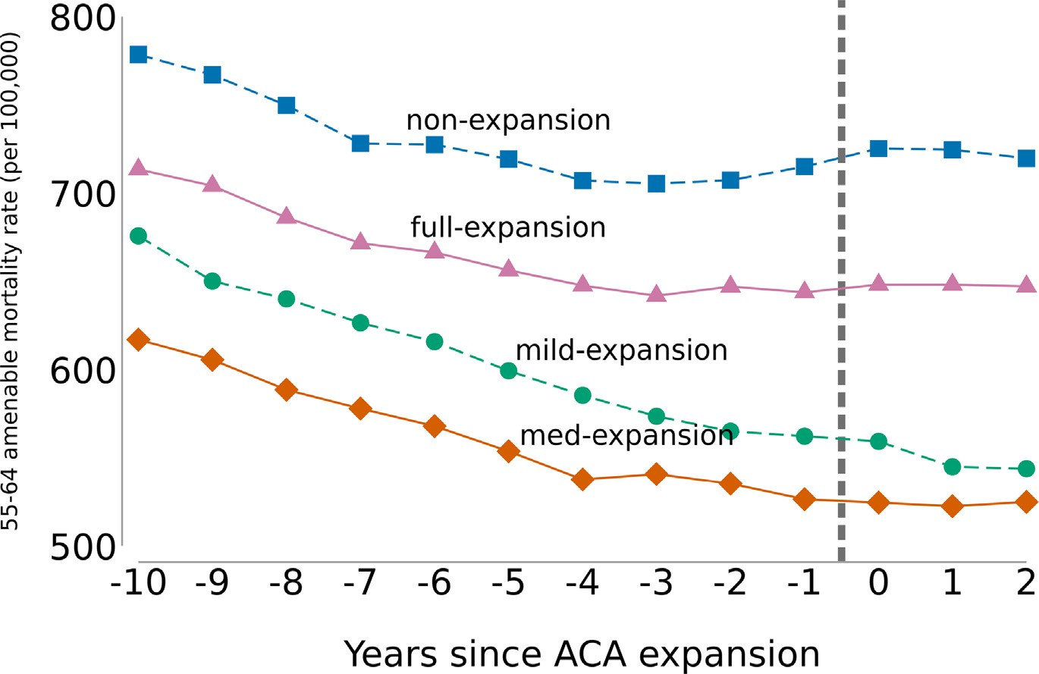

Fig. A1. Time trends in amenable mortality for persons aged 55–64. Note: Number along the x-axis indicates years since most Medicaid expansion. For non-expansion states,
t ¼ 0 corresponds to 2014. Years included in this figure are 2004 to 2016. Health care amenable causes of death follow Nolte and McKee (2003).

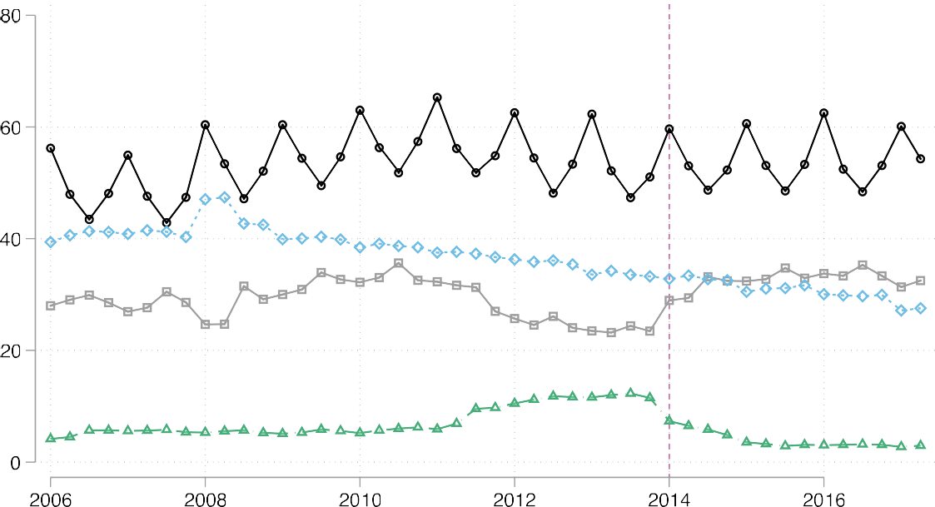

Fig. A2. Number of Arizona inpatient stays by payor and year. Author reproduction of HCUP figure using HCUP Fast Stats at https://www.hcup-us.ahrq.gov/faststats/ StatePayerServlet?state1 = AZ. Accessed June 2018. Arizona had a S.1931 program providing Medicaid up to 106% FPL for parents. It also had a limited program for 7 childless adults, under a § 1115 waiver, starting in 2001, which was closed to new entrants since 2011.23 Whether to treat Arizona as a full expansion state or an early expansion state turns on how many childless adults were still covered at the ACA onset in 2014, given churn in eligibility. The tail off in hospital admissions with Medicaid payment, and jump at the start of 2014 (with uninsured admissions showing the opposite pattern), persuades us that Arizona should be treated as a regular expansion state.

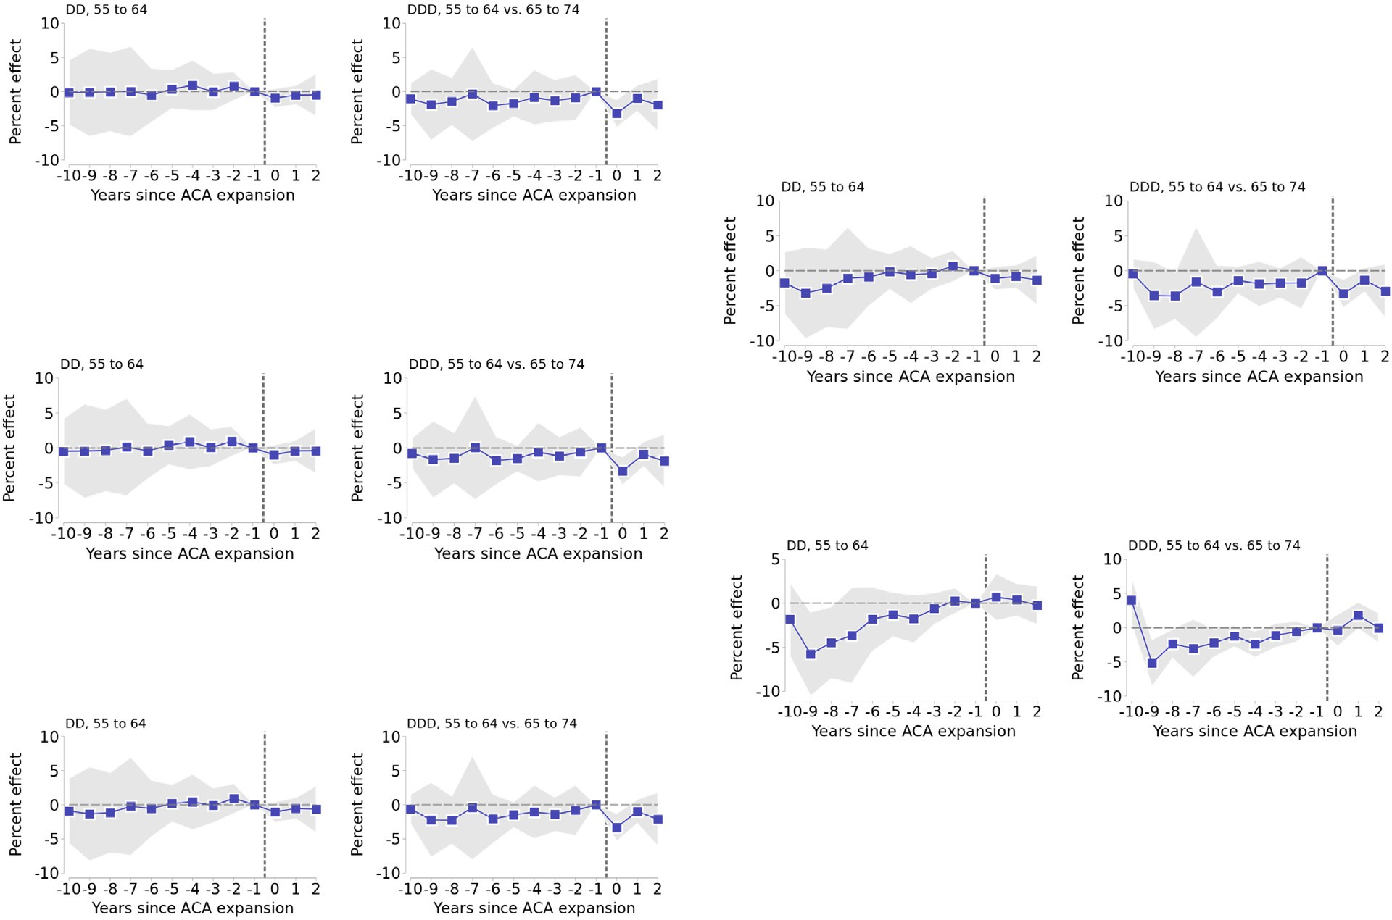

Fig. A3. Event studies with different windsorization of weights. Note: Number along the x-axis indicates years since most Medicaid expansion. For non-expansion states, t ¼ 0 corresponds to 2014. Years included in this figure are 2004 to 2016. Since each dependent variable is a natural log transform of the healthcare amendable death rate per 100,000, we transform each regression coefficient by 100(exp(coef.)-1) and the standard errors using the delta method. Thus each reported coefficient can be interpreted as the percent effect of Medicaid expansion t years ago on the healthcare amenable mortality rate for a given age group (i.e., A coefficient of -2 would mean that the mortality rate would decrease by 2%). Point estimates are depicted by blue squares and come from regressions analogous to Eq. 2, except that in each sub-figure a different trimming is used. 95% confidence intervals are displayed by gray area and are calculated using robust standard errors clustered at the state level.

A. No income restrictions (as in mortality data)
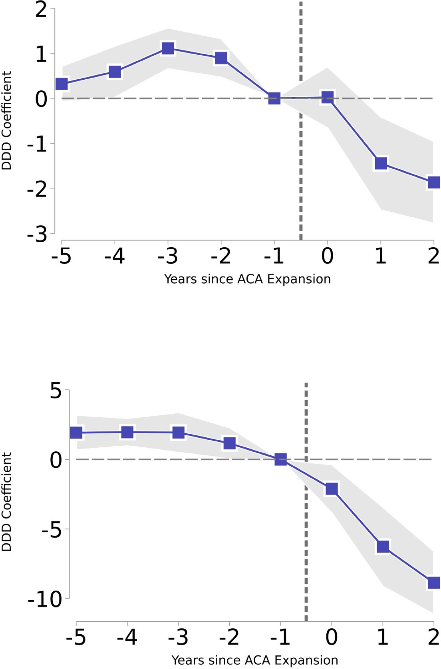

B. Restricting to those with income :S 138% FPL

Fig. A4. The impact of Medicaid expansion on the percentage uninsured aged 55 to 64 is the largest for lower income individuals. Note: Number along the x-axis indicates years since most Medicaid expansion. For non-expansion states, t ¼ 0 corresponds to 2014. Data come from the American Community Survey and are at the county-level covering 2008 to 2016. Each reported coefficient can be interpreted as the percent effect of Medicaid expansion t years ago on the percentage of those without health insurance in each group. Point estimates are depicted by blue squares and come from regressions analogous to Eq. 2, but for the triple difference specification. 95% confidence intervals are displayed by gray area and are calculated using robust standard errors clustered at the state level.

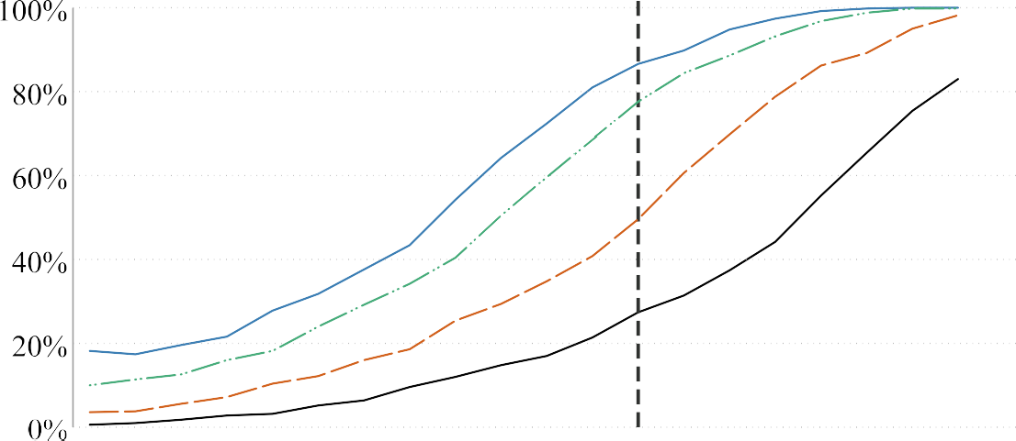
Fig. A5. Power.

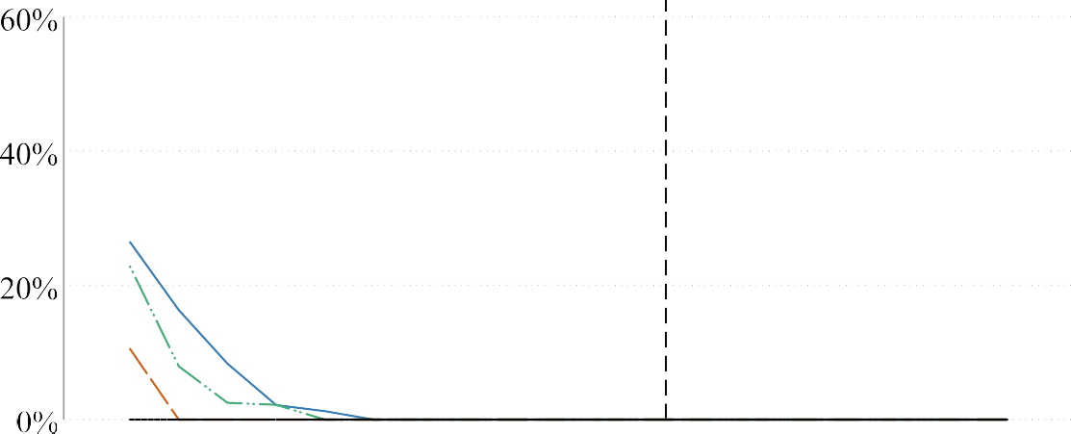

Fig. A6. Sign error.

? 15
(.)
�4-i
(l)
"d
(l)
s
rF.J
10
0
s

(l)
0
(.)
Exaggeration Ratio; DD, 0-64, All Cause Mortality

MDE
I

OfJ
·-
CF.J
'--'
.grF.J
§
(l)
:::8
5

0
\
I I I
I

0 1 2 3 4 5
Imposed Population Effect (Percent Reduction in Non-Elderly Mortality)
- a =.10 - a =.05 - a =.01 - a =.001
Fig. A7. Magnitude error.

100%
Likelihood of believable coefficient; DD, 0-64, All Cause Mortality
MDE

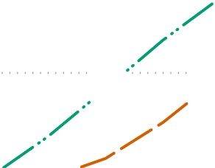

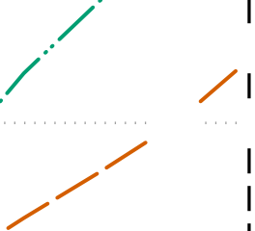
80%
_,,,...
/1

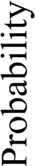
60%

40%

20%

0%

0 1 2 3 4 5
Imposed Population Effect (Percent Reduction in Non-Elderly Mortality)
- a =.10 - a =.05 - a =.01 - a =.001
Fig. A8. Believability.

Covariate Balance for Full-Expansion and Non-Expansion States.

Full Expansion States Non-Expansion States Difference t-stat Normalized Difference
(1) (2) (3) (4)
% 55–64 years 12.68 12.35 0.31 0.08
% 65–74 years 16.61 16.85 0.67 -0.05
% Female 50.23 50.43 0.76 -0.03
% Female, 55–64 years 4.96 4.85 0.21 0.05
% Female, 65–74 years 7.27 7.35 0.22 -0.03
% White 84.15 87.17 0.81 -0.18
% White, 55–64 years 9.97 10.23 0.94 -0.06
% White, 65–74 years 13.81 14.53 0.94 -0.14
% Black 9.59 8.29 0.62 0.10
% Black, 55–64 years 1.79 1.53 0.63 0.11
% Black, 65–74 years 1.77 1.55 0.66 0.09
% Hispanic 4.03 2.98 0.52 0.11
% Hispanic, 55–64 years 0.59 0.37 0.81 0.14
% Hispanic, 65–74 years 0.63 0.46 0.54 0.09
% In Poverty 14.92 13.42 1.44 0.24
% Managed Care Penetration 24.86 22.92 0.40 0.18
% Disabled (ages 18–64) 16.36 16.83 0.59 -0.08
Mean Per Capita Income 40364.57 41696.06 0.52 -0.15
Median Household Income 51284.70 52565.73 0.29 -0.12
Unemployment Rate, 16+ 8.68 7.55 2.81 0.38
% with Diabetes 8.91 8.67 0.45 0.12
% Physically Inactive 22.59 22.38 0.13 0.04
% Obese 27.97 27.74 0.04 0.05
% Smoker 21.80 21.51 0.42 0.07
Physicians/1,000 people 3.12 3.04 0.48 0.05
% Uninsured (18–64 years) 18.69 18.27 0.32 0.07
% Uninsured (50–64 years) 12.88 12.91 0.02 -0.01
% Uninsured (18–64 years), 6138% FPL 37.80 39.57 0.33 -0.23
% Uninsured (50–64 years), 6138% FPL 32.87 34.97 0.81 -0.32
Death Rate 859.58 845.20 0.34 0.05
Death Rate 55–64 years 852.93 797.00 1.41 0.16
Death Rate 65–74 years 1861.27 1786.72 0.93 0.12
Non-amenable Death Rate 589.41 576.92 0.38 0.06
Non-amenable Death Rate 55–64 years 644.03 607.40 1.11 0.12
Npn-amenable Death Rate 65–74 years 1498.39 1436.08 0.89 0.12
Amenable Death Rate 270.16 268.29 0.16 0.02
Amenable Death Rate 55–64 years 208.91 189.60 1.71 0.14
Amenable Death Rate 65–74 years 362.88 350.64 0.50 0.06
Note: Table shows summary statistics for county-level covariates and mortality for Full-Expansion and Non-Expansion states during pre-expansion period, using ATTx population weights. T-statistics use two-sample t-test for difference and robust standard errors with state clusters. Normalized difference is a sample-size independent measure of the difference between two means, scaled by standard deviation). State groups are defined in Table A1. Mortality rates are per 100,000 persons. Dollar amounts are in 2010 **. See Table A5 in the Appendix to see the same Table, but with population weights instead of ATTxPop weights.

Treatment effect estimates by subgroup.
 |  | State-level |  |  | County-level
 | DD 55–64 | DD 65–74 | DDD | DD 55–64 | DD 65–74 | DDD
 | (1) | (2) | (3) | (4) | (5) | (6)
Healthcare amenable mortality | -2.32** | -0.98 | -1.53* | -0.65 | 0.41 | -0.85
 | (1.01) | (0.89) | (0.77) | (1.74) | (0.80) | (0.94)
Non-amenable mortality | 1.45 | 3.32*** | -1.73 | 2.60 | 0.90 | 1.58
 | (1.35) | (0.76) | (1.12) | (2.36) | (1.12) | (1.79)
All mortality | -1.27 | -0.18 | -1.32* | 0.28 | 0.57 | -0.18
 | (0.97) | (0.77) | (0.72) | (1.70) | (0.68) | (1.01)
Respiratory mortality | -5.34*** | -4.04** | -2.69* | -7.19 | -2.64 | -5.75
 | (1.56) | (1.54) | (1.47) | (4.28) | (2.49) | (6.73)
Cancer mortality | -1.50* | 0.25 | -1.71 | 0.73 | 1.73*** | -0.52
 | (0.82) | (0.86) | (1.05) | (1.83) | (0.60) | (1.72)
Cardiac mortality | -0.97 | -0.55 | -0.80 | 0.58 | -0.15 | 0.93
 | (1.17) | (1.13) | (0.91) | (1.77) | (0.83) | (1.52)
HIV mortality | -2.40 | 0.97 | -5.33 | 0.57 | 10.63 | -7.16
 | (3.94) | (5.71) | (9.17) | (4.18) | (7.69) | (9.51)
Diabetes mortality | -3.42 | -2.06 | -1.25 | -4.44 | -2.35 | -2.66
 | (2.58) | (2.50) | (1.26) | (2.74) | (5.05) | (2.42)
Male, amenable mortality | -1.48 | -0.10 | -1.88** | -0.15 | 1.24 | -1.01
 | (1.10) | (0.86) | (0.83) | (1.91) | (1.02) | (1.13)
Female, amenable mortality | -3.51*** | -2.14* | -1.18 | -1.45 | -0.71 | -0.31
 | (1.09) | (1.07) | (1.01) | (1.64) | (0.87) | (1.47)
White, amenable mortality | -2.18** | -1.41 | -0.89 | 0.31 | 0.82 | -0.08
 | (0.93) | (0.90) | (0.89) | (1.68) | (0.76) | (1.04)
Black, amenable mortality | -3.72*** | 0.99 | -5.24*** | -5.82* | 0.44 | -8.55***
 | (1.15) | (1.11) | (1.21) | (3.17) | (2.82) | (2.85)
Hispanic, amenable mortality | -9.44** | -3.39 | -5.67 | -14.81** | -5.61 | -5.33
 | (3.75) | (3.41) | (3.73) | (6.66) | (6.18) | (4.61)
Weights | ATTxPop | ATTxPop | ATTxPop | ATTxPop | ATTxPop | ATTxPop
Unit fixed-effects (state or county) | Yes | Yes | Yes | Yes | Yes | Yes
Year fixed-effects | Yes | Yes | Yes | Yes | Yes | Yes
Covariates | Yes | Yes | Yes | Yes | Yes | Yes
Note: * p < 0.1, ** p < 0.05, *** p < 0.01. Robust standard errors clustered at the state level in parentheses. Each DD regression corresponds to Eq. 1 while each triple-difference regression corresponds to Eq. 3, except that we change the subgroup or cause of death as noted. Years included in this table are 2004 to 2016. Each dependent variable is a natural log transform of the death rate per 100,000 population for the respective group. We transform each regression coefficient by 100(exp(coef.)-1) and the standard errors using the delta method. Thus each reported coefficient can be interpreted as the percent effect of Medicaid expansion on the specific mortality rate for a given age group (i.e., a coefficient of -2 would mean that the mortality rate would decrease by 2%). Covariates include % Medicare Advantage Penetration, % Medicare enrollees receiving social security disability benefits, Per Capita Income, Median Household Income, % Persons in Poverty, Unemployment Rate, 16+, Number of individuals with diabetes as percent of the population, Age-adjusted percent of the population that is physically inactive, Percent of population that is obese, Smoking Prevalence (all genders), Non-Federal Active MDs per 1000 people.

Table A4
The effect of Medicaid expansion on the percentage uninsured by age group and demographic, using population weights.

ACS (County-level) SAHIE
DD 55–64 DD 65–74 DDD State DD 50–64 County DD 50–64
(1) (2) (3) (4) (5)
All -1.19*** -0.01 -1.16** -1.23** -1.21** (0.42) (0.06) (0.47) (0.51) (0.47)
Female -1.32*** 0.01 -1.29** -1.35** -1.31*** (0.46) (0.07) (0.50) (0.53) (0.48)
Male -1.07** -0.03 -1.03** -1.14** -1.10** (0.43) (0.06) (0.48) (0.49) (0.47)
White (non-Hispanic) -1.51*** -0.02 -1.37*** -1.54*** (0.28) (0.04) (0.35) (0.37)
Black (non-Hispanic) -2.25*** 0.09 -2.63** -2.09** (0.80) (0.21) (1.03) (0.78)
Other (non-Hispanic) -1.44 -0.57 -2.12*
(0.97) (0.45) (1.11)
Hispanic -0.04 0.12 0.09 -0.38
(1.47) (0.52) (1.59) (1.18)
Elementary school -2.74** -0.08 -2.93** (1.32) (0.39) (1.09)
High school incomplete -4.24*** -0.27 -4.26*** (0.71) (0.20) (0.83)
High school complete -1.48** 0.08 -1.37** (0.56) (0.07) (0.65)
Some college -0.87** -0.07 -0.79** (0.36) (0.05) (0.38)
Below 138% FPL -6.54*** -0.09 -6.26*** -6.38*** -6.43*** (0.88) (0.25) (1.00) (0.95) (0.95)
138%-400% FPL -1.01 -0.01 -0.91 -1.00 -1.27*
(0.60) (0.06) (0.67) (0.76) (0.71)
Observations 369 369 738 451 19628 Unit fixed-effects (state or county) Yes Yes Yes Yes Yes Year fixed-effects Yes Yes Yes Yes Yes
Covariates Yes Yes Yes Yes Yes
Weights used Pop Pop Pop Pop Pop

Note: * p < 0.1, ** p < 0.05, *** p < 0.01. Robust standard errors clustered at the state-level are reported in parentheses. Each estimate comes from a separate regression and the point estimate can be interpreted as the effect of Medicaid expansion on the percent uninsured for a given group (i.e., a coefficient of -2 would mean that those without insurance in that group decreased by 2 percentage points). ACS data refers to the American Community Survey and are at the county-level covering 2008 to 2016. SAHIE data refers to the Census Bureau’s Small Area Health Insurance Estimates and are reported at both state and county-levels covering 2006 to 2016. See Table 2 in main text to see the same Table, but with ATTxPop weights rather than population weights.

Table A5
Covariate Balance for Full-Expansion and Non-Expansion States Using Population Weights.

Full Expansion States Non-Expansion States Difference t-stat Normalized Difference
(1) (2) (3) (4)
% 55–64 years 12.68 13.72 2.61 -0.26
% 65–74 years 16.61 17.64 2.59 -0.22
% Female 50.23 49.37 2.12 0.15
% Female, 55–64 years 4.96 5.38 2.11 -0.19
% Female, 65–74 years 7.27 7.62 1.56 -0.12
% White 84.15 75.02 3.11 0.56
% White, 55–64 years 9.97 9.44 0.87 0.14
% White, 65–74 years 13.81 13.17 1.45 0.12
% Black 9.59 15.52 2.69 -0.48
% Black, 55–64 years 1.79 2.96 2.69 -0.48
% Black, 65–74 years 1.77 2.91 2.62 -0.45
% Hispanic 4.03 7.85 1.09 -0.39
% Hispanic, 55–64 years 0.59 1.06 0.90 -0.30
% Hispanic, 65–74 years 0.63 1.25 1.06 -0.32
% In Poverty 14.92 17.16 3.14 -0.35
% Managed Care Penetration 24.86 23.64 0.77 0.11
% Disabled (ages 18–64) 16.36 17.58 1.59 -0.20
Mean Per Capita Income 40364.57 37594.69 2.13 0.30
Median Household Income 51284.70 46819.56 2.29 0.42
Unemployment Rate, 16+ 8.68 8.12 1.47 0.19
% with Diabetes 8.91 9.77 2.78 -0.43
% Physically Inactive 22.59 24.52 1.97 -0.39
% Obese 27.97 29.09 1.29 -0.26
% Smoker 21.80 21.49 0.44 0.08
Physicians/1,000 people 3.12 2.67 2.63 0.27
% Uninsured (18–64 years) 18.69 25.06 3.23 -1.09
% Uninsured (50–64 years) 12.88 17.44 3.33 -1.03
% Uninsured (18–64 years), 6138% FPL 37.80 46.97 3.46 -1.21
% Uninsured (50–64 years), 6138% FPL 32.87 39.48 3.73 -1.01
Death Rate 859.58 825.58 0.50 0.12
Death Rate 55–64 years 852.93 933.79 2.20 -0.23
Death Rate 65–74 years 1861.27 1939.68 0.71 -0.13
Non-amenable Death Rate 589.41 557.11 0.81 0.16
Non-amenable Death Rate 55–64 years 644.03 701.74 1.84 -0.20
Non-amenable Death Rate 65–74 years 1498.39 1540.86 0.35 -0.08
Amenable Death Rate 270.16 268.47 0.40 0.02
Amenable Death Rate 55–64 years 208.91 232.05 2.60 -0.17
Amenable Death Rate 65–74 years 362.88 398.81 1.71 -0.17

Note: Table shows summary statistics for county-level covariates and mortality for Full-Expansion and Non-Expansion states during the pre-expansion period using county population weights. t-statistics use two-sample t-test for difference and robust standard errors with state clusters. Normalized difference is a sample-size independent measure of the difference between two means, scaled by standard deviation). State groups are defined in Table A1. Mortality rates are per 100,000 persons. Dollar amounts are in 2010 **. See Table A2 in the main text to see the same Table, but with ATTxPop weights instead of population weights.

References

Arnold, Benjamin F., Hogan, Daniel R., Colford, John M., Hubbard, Alan E., 2011. ”Simulation methods to estimate design power: An overview for applied research.” BMC Med. Res. Methodol., Vol. 11.
Baicker, Katherine, Taubman, Sarah L., Allen, Heidi L., Bernstein, Mira, Gruber, Jonathan H., Newhouse, Joseph P., Schneider, Eric C., Wright, Bill J., Zaslavsky, Alan M., Finkelstein, Amy N., 2013. The Oregon Experiment — Effects of Medicaid on Clinical Outcomes. N. Engl. J. Med. 368 (18), 1713–1722.
Banerjee, Abhijit, Karlan, Dean, Zinman, Jonathan, 2015. Six Randomized Evaluations of Microcredit: Introduction and Further Steps. Am. Econ. J.: Appl. Econ. 7 (1), 1–21.
Bertrand, Marianne, Duflo, Esther, Mullainathan, Sendhil, 2004. How Much Should We Trust Differences-In-Differences Estimates? Q. J. Econ. 119 (1), 249–275.
Borgschulte, Mark, Vogler, Jacob, 2020. Did the ACA Medicaid Expansion Save Lives?
J. Health Econ. 72, 102333.
Brook, Robert H., Ware, John E., Rogers, William H., Keeler, Emmett B., Davies, Allyson R., Donald, Cathy A., Goldberg, George A., Lohr, Kathleen N., Masthay, Patricia C., Newhouse, Joseph P., 1983. Does Free Care Improve Adults’ Health?: Results from a Randomized Controlled Trial. N. Engl. J. Med. 309 (23), 1426–1434.
Burlig, Fiona, Preonas, Louis, Woerman, Matt, 2020. Panel data and experimental design. J. Dev. Econ. 144, 102458.
Button, Katherine S., Ioannidis, John P.A., Mokrysz, Claire, Nosek, Brian A., Flint, Jonathan, Robinson, Emma S.J., Munafò, Marcus R., 2013. Power failure: why small sample size undermines the reliability of neuroscience. Nat. Rev. Neurosci. 14 (5), 365–376.
Card, David, Dobkin, Carlos, Maestas, Nicole, 2004. ”The Impact of Nearly Universal Insurance Coverage on Health Care Utilization and Health: Evidence from Medicare,”Technical Report w10365. National Bureau of Economic Research, Cambridge, MA.
Card, David, Dobkin, Carlos, Maestas, Nicole, 2009. Does Medicare Save Lives?
Quart. J. Econ. 124 (2), 597–636.
Case, Anne, Deaton, Angus, 2015. Rising morbidity and mortality in midlife among white non-Hispanic Americans in the 21st century. Proc. Nat. Acad. Sci. 112 (49), 15078–15083.
Chetty, Raj, Stepner, Michael, Abraham, Sarah, Lin, Shelby, Scuderi, Benjamin, Turner, Nicholas, Bergeron, Augustin, Cutler, David, 2016. The Association Between Income and Life Expectancy in the United States, 2001–2014. JAMA 315 (16), 1750.
Courtemanche, Charles, Marton, James, Ukert, Benjamin, Yelowitz, Aaron, Zapata, Daniela, 2017. Early Impacts of the Affordable Care Act on Health Insurance Coverage in Medicaid Expansion and Non-Expansion States. J. Policy Anal. Manage. 36 (1), 178–210.
Croke, Kevin, Hicks, Joan Hamory, Hsu, Eric, Kremer, Michael, Miguel, Edward, 2016. ”Does Mass Deworming Affect Child Nutrition? Meta-analysis, Cost-Effectiveness, and Statistical Power,”Technical Report 22382. National Bureau of Economic Research, Cambridge, MA.
Damiano, Peter C., Bentler, Suzanne E., Robinson, Erin, Park, Ki H., Momany, Elizabeth T., 2013. ”Evaluation of the IowaCare Program. Information about the Medical Home Expansion.”.
Davern, Michael, Klerman, Jacob Alex, Baugh, David K., Call, Kathleen Thiede, Greenberg, George D., 2009. An Examination of the Medicaid Undercount in the Current Population Survey: Preliminary Results from Record Linking. Health Serv. Res. 44 (3), 965–987.
Bradford De Long, J., Lang, Kevin, 1992. Are all Economic Hypotheses False? J. Polit.
Econ. 100 (6), 1257–1272.
Doyle, Joseph J., 2005. Health Insurance, Treatment and Outcomes: Using Auto Accidents as Health Shocks. Rev. Econ. Stat. 87 (2), 256–270.
Dunn, Abe, Shapiro, Adam Hale, 2019. Does Medicare Part D Save Lives? Am. J. Health Econ. 5 (1), 126–164.
Finkelstein, A., 2007. The Aggregate Effects of Health Insurance: Evidence from the Introduction of Medicare. Q. J. Econ. 122 (1), 1–37.

Finkelstein, Amy, McKnight, Robin, 2008. What Did Medicare Do? The Initial Impact of Medicare on Mortality and out of Pocket Medical Spending. J. Public Econ. 92 (7), 1644–1668.
Finkelstein, Amy, Taubman, Sarah, Wright, Bill, Bernstein, Mira, Gruber, Jonathan, Newhouse, Joseph P., Allen, Heidi, Baicker, Katherine, Oregon Health Study Group, 2012. ‘‘The Oregon Health Insurance Experiment: Evidence from the First Year.” Quart. J. Econ., Vol. 127, No. 3, pp. 1057–1106.
Gallet, Craig A., Doucouliagos, Hristos, 2017. The impact of healthcare spending on health outcomes: A meta-regression analysis. Social Sci. Med. 179, 9–17.
Gates, Alexandra, Rudowitz, Robin, 2014. ‘‘Wisconsin’s BadgerCare Program and the ACA,”Technical report, Kaiser Family Foundation.
Gelman, Andrew, Carlin, John, 2014. Beyond Power Calculations: Assessing Type S (Sign) and Type M (Magnitude) Errors. Perspect. Psychol. Sci. 9 (6), 641–651.
Gelman, Andrew, Hill, Jennifer, 2006. ”Sample size and power calculations,” in Data Analysis Using Regression and Multilevel/Hierarchical Models, pp. 437–456.
Gerin, William, Kapelewski, Christine, Page, Niki L., 2017. Writing the NIH Grant Proposal: A Step-by-Step Guide. SAGE Publications Inc, Los Angeles, CA, p. 232. Gilbert, Gregory E., Prion, Susan, 2016. Making Sense of Methods and Measurement: The Danger of the Retrospective Power Analysis. Clin. Simul. Nurs. 12 (8), 303–
304.
Goldin, Jacob, Lurie, Ithai Z, McCubbin, Janet, 2021. Health Insurance and Mortality: Experimental Evidence from Taxpayer Outreach. Quart. J. Econ., 53
Gouveia, Nelson, Fletcher, Tony, 2000. Time Series Analysis of Air Pollution and Mortality: Effects by Cause, Age and Socioeconomic Status. J. Epidemiol. Community Health 54 (10), 750–755.
Hannon, Susan J., Martin, Kathy, Thomas, Len, Schieck, Jim, 1993. Investigator Disturbance and Clutch Predation in Willow Ptarmigan: Methods for Evaluating Impact. J. Field Ornithol. 64 (4), 575–586.
Heberlein, Martha, Brooks, Tricia, Guyer, Jocelyn, Artiga, Samantha, Stephens, Jessica, 2011. ”Holding Steady, Looking Ahead: Annual Findings of a 50-State Survey of Eligibility Rules, Enrollment and Renewal Procedures, and Cost-Sharing Practices in Medicaid and CHIP, 2010–2011,”Technical report, Kaiser Commission on Medicaid and the Uninsured.
Hoenig, John M., Heisey, Dennis M., 2001. The Abuse of Power: The Pervasive Fallacy of Power Calculations for Data Analysis. Am. Statist. 55 (1), 19–24.
Hsiang, Solomon M., Burke, Marshall, Miguel, Edward, Meng, Kyle, Cane, Mark, 2009. ”Analysis of statistical power reconciles drought-conflict results in Africa.”.
Huh, Jason, Reif, Julian, 2017. Did Medicare Part D reduce mortality? J. Health Econ.
53, 17–37.
Ioannidis, John P A, 2005. Why Most Published Research Findings Are False. PLoS Med. 2 (8), e124.
Ioannidis, John P.A., Stanley, T.D., Doucouliagos, Hristos, 2017. The Power of Bias in Economics Research. Econ. J. 127 (605), F236–F265.
Johnson, Garrett A., Lewis, Randall A., Reiley, David H., 2017. When Less Is More: Data and Power in Advertising Experiments. Market. Sci. 36 (1), 43–53.
Kaestner, Robert, 2021. Mortality and Science: A Comment on Two Articles on the Effects of Health Insurance on Mortality. Econ. J. Watch 18 (2), 192–211.
Kaiser Family Foundation, 2018. ”Status of State Action on the Medicaid Expansion Decision.”.
Keeler, E.B., Brook, Robert H., Goldberg, George A., Kamberg, Caren J., Newhouse, Joseph P., 1985. ”How Free Care Reduced Hypertension in the Health Insurance Experiment,” JAMA: The. J. Am. Med. Assoc. 254 (14), 1926–1931.
Kenney, Genevieve M., Lynch, Victoria, Haley, Jennifer, Huntress, Michael, 2012. Variation in Medicaid Eligibility and Participation among Adults: Implications for the Affordable Care Act. Inquiry 49 (3), 231–253.
Kowalski, Amanda, 2020. ”Reconciling Seemingly Contradictory Results from the Oregon Health Insurance Experiment and the Massachusetts Health Reform,” Technical Report w24647. National Bureau of Economic Research, Cambridge, MA.
Levy, Helen G., Meltzer, David, 2004. What Do We Really Know about Whether Health Insurance Affects Health? In: McLaughlin, Catherine G. (Ed.), Health Policy and the Uninsured. Urban Institute Press, Washington D.C.
Levy, Helen G., Meltzer, David, 2008. The Impact of Health Insurance on Health.
Annu. Rev. Public Health 29 (1), 399–409.
Lewis, Randall A., Rao, Justin M., 2015. The unfavorable economics of measuring the returns to advertising. Quart. J. Econ. 130 (4), 1941–1973.
Lewis, Randall A., Reiley, David H., 2014. Online Ads and Offline Sales: Measuring the Effect of Retail Advertising via a Controlled Experiment on Yahoo! Quant. Market. Econ. 12 (3), 235–266.
Lindo, Jason M., 2015. Aggregation and the Estimated Effects of Economic Conditions on Health. J. Health Econ. 40, 83–96.
Lou, Moghtaderi, Markus, A., Dor, A., 2018. ”Impact of Medicaid Expansion on Total Revenue of Community Health Centers by Funding Sources.”.
Marton, James, Yelowitz, Aaron, 2015. Health Insurance Generosity and Conditional Coverage: Evidence from Medicaid Managed Care in Kentucky: Medicaid Conditional Coverage. South. Econ. J. 82 (2), 535–555.
Maxwell, Scott E., 2004. The Persistence of Underpowered Studies in Psychological Research: Causes, Consequences, and Remedies. Psychol. Methods 9 (2), 147–163.
McClellan, Chandler, 2017. The Affordable Care Act’s Dependent Care Coverage and Mortality. Med. Care 55 (5), 6.
McCloskey, Deirdre N, Ziliak, Stephen T, 1996. The Standard Error of Regressions. J. Econ. Literature 34 (1), 97–114.
McCloskey, Donald, 1985. The Loss Function Has Been Mislaid: The Rhetoric of Significance Tests. Am. Econ. Rev.: Papers and Proc. 75 (2), 201–205.
Miller, Sarah, Johnson, Norman, Wherry, Laura, 2021. Medicaid and Mortality: New Evidence from Linked Survey and Administrative Data. Q. J. Econ. 136, 1783–1829.
Newhouse, Joseph P. (1993) Free for All? Lessons from the Rand Health Insurance Experiment, Cambridge, Mass: Harvard University Press.
NIH (2016) ‘‘Reviewer Guidance on Rigor and Transparency: Research Project Grant and Mentored Career Development Applications.”
Nolte, Ellen, McKee, Martin, 2003. Measuring the health of nations: analysis of mortality amenable to health care. BMJ 327 (7424), 1129.
Polsky, Daniel, Richards, Michael, Basseyn, Simon, Wissoker, Douglas, Kenney, Genevieve M., Zuckerman, Stephen, Rhodes, Karin V., 2015. Appointment Availability after Increases in Medicaid Payments for Primary Care. N. Engl. J. Med. 372 (6), 537–545.
Powell, David, 2018. Imperfect Synthetic Controls: Did the Massachusetts Health Care Reform Save Lives?, p 44.
Senn, S.J., 2002. Power is indeed irrelevant in interpreting completed studies. BMJ 325 (7375). 1304–1304.
Simon, Kosali, Soni, Aparna, Cawley, John, 2017. The Impact of Health Insurance on Preventive Care and Health Behaviors: Evidence from the First Two Years of the ACA Medicaid Expansions: Impact of Health Insurance on Preventive Care and Health Behaviors. Journal of Policy Analysis and Management 36 (2), 390–417. Sommers, Benjamin D., Baicker, Katherine, Epstein, Arnold M., 2012. Mortality and Access to Care among Adults after State Medicaid Expansions. N. Engl. J. Med.
367 (11), 1025–1034.
Sommers, Benjamin D., Buchmueller, Thomas, Decker, Sandra L., Carey, Colleen, Kronick, Richard, 2013. The Affordable Care Act Has Led To Significant Gains In Health Insurance And Access To Care For Young Adults. Health Aff. 32 (1), 165–
174. PMID: 23255048.
Sommers, Benjamin D., Long, Sharon K., Baicker, Katherine, 2014. Changes in Mortality After Massachusetts Health Care Reform: A Quasi-Experimental Study. Ann. Intern. Med. 160 (9), 585.
Stigler, Stephen, 1977. Do robust estimators work with real data? Ann. Stat. 5 (6), 1055–1098.
Taylor-Robinson, David C., Nicola Maayan, Karla Soares-Weiser, Sarah Donegan, and Paul Garner (2015) ”Deworming drugs for soil-transmitted intestinal worms in children: effects on nutritional indicators, haemoglobin, and school performance,” Cochrane Database of Systematic Reviews, Vol. 2015, No. 7.
Weathers, Robert R., Stegman, Michelle, 2012. The Effect of Expanding Access to Health Insurance on the Health and Mortality of Social Security Disability Insurance Beneficiaries. J. Health Econ. 31 (6), 863–875.
Wehby, George L., Lyu, Wei, 2018. The Impact of the ACA Medicaid Expansions on Health Insurance Coverage through 2015 and Coverage Disparities by Age, Race/ Ethnicity, and Gender. Health Serv. Res. 53 (2), 1248–1271.
Wherry, Laura R., Miller, Sarah, 2016. Early Coverage, Access, Utilization, and Health Effects Associated With the Affordable Care Act Medicaid Expansions: A Quasi-Experimental Study. Ann. Intern. Med. 164 (12), 795.
Zhang, Le, Ortmann, Andreas, 2013. ”Exploring the Meaning of Significance in Experimental Economics,”Technical report.
Ziliak, Stephen T., McCloskey, Deirdre N., 2004. Size matters: the standard error of regressions in the American Economic Review. J. Socio-Econ. 33 (5), 527–546.

